# VoteX – Campaign Compass

MINI PROJECT REPORT

By

**SANJAY PONNAMBALAM N (RA2211026010136)**

**KIRUSHAKKARASU KT (RA2211026010134)**

Under the guidance of   
**Dr. S. Sadagopan***In partial fulfilment for the Course*

**21CSC205P – DATABASE MANAGEMENT SYSTEM**

in **B.Tech CSE with specialization in AI & ML**

**FACULTY OF ENGINEERING AND TECHNOLOGY**

**SCHOOL OF COMPUTING**

**SRM INSTITUTE OF SCIENCE AND TECHNOLOGY**

**KATTANKULATHUR**

**MAY 2024**

**SRM INSTITUTE OF SCIENCE AND TECHNOLOGY**

**(Under Section 3 of UGC Act, 1956)**

**BONAFIDE CERTIFICATE**

Certified that this mini project report for the course **21CSC205P** **DATABASE MANAGEMENT SYSTEM** entitled in "**VoteX – Campaign Compass**" is the bonafide work of **Sanjay Ponnambalam (RA2211026010136), Kirushakkarasu KT (RA2211026010134)** who carried out the work under my supervision.

# SIGNATURE

**Dr. S. Sadagopan**

**Faculty-In-Charge Dr. Annie Uthra**

# Associate Professor Head of Department

Department of CINTEL Department of CINTEL

SRMIST SRMIST

Kattankulathur Kattankulathur

# ACKNOWLEDGEMENT

We express our heartfelt thanks to our honorable **Vice Chancellor Dr. C. MUTHAMIZHCHELVAN**, for being the beacon in all our endeavors.

We would like to express my warmth of gratitude to our **Registrar Dr. S. Ponnusamy,** for his encouragement.

We express our profound gratitude to our **Dean (Faculty of Engineering and Technology) Dr. T. V. Gopal,** for bringing out novelty in all executions.

We would like to express my heartfelt thanks to Chairperson, School of Computing **Dr. Revathi Venkataraman,** for imparting confidence to complete my course project.

We extend my gratitude to our **HoD, Dr. Annie Uthra, Professor & Head, Department of Computational Intelligence** and my Departmental colleagues for their Support.

We are highly thankful to our Course project Faculty **Dr. S. Sadagopan, Associate Professor, Department of Computational Intelligence,** for hisassistance, timely suggestion and guidance throughout the duration of this course project.

**I**

**ABSTRACT**

Political Campaign Management Software revolutionizes the electoral landscape by democratizing access to resources for candidates of all backgrounds. Through digital platforms, it empowers grassroots organizing, decentralizes decision-making, and fosters a culture of participation and collaboration. By providing robust tools for internal democracy and accountability, the software sets a new standard for political integrity, garnering trust and confidence from members, supporters, and the broader public. At its core, the software aims to level the playing field, ensuring that every candidate has the opportunity to compete effectively and transparently. It provides features for comprehensive voter engagement, streamlined campaign planning, efficient fundraising management, and insightful data analytics. These tools enable candidates to reach and mobilize voters with precision, while also fostering genuine connections within local communities. By embracing innovation and technology, our software empowers candidates to navigate the complexities of modern campaigning with ease. From coordinating volunteer efforts to complying with campaign finance regulations, the software streamlines every aspect of the campaign process. Moreover, its emphasis on transparency and accountability reinforces public trust in the political process, laying the foundation for a more inclusive and participatory democracy. In essence, our Political Campaign Management Software represents a paradigm shift in electoral campaigning, championing equity, inclusivity, and integrity. It embodies our commitment to democratizing access to political resources and empowering candidates to enact positive change in their communities.

**II**

**TABLE OF CONTENTS**

|  |  |  |
| --- | --- | --- |
| **Chapter No** | **Chapter Name** | **Page No** |
|  | **INTRODUCTION** | **1-6** |
|  | * 1. Problem Statement | 1-2 |
|  | 1.2. Entities and Relationship | 2-3 |
|  | 1.3. Construction of database | 4-6 |
|  | **DESIGN OF RELATIONAL SCHEMAS** | **7-12** |
|  | 2.1. Creation of Database Tables for the project. | 9-12 |
|  | **COMPLEX QUERIES USING SQL** | **13** |
|  | 3.1. Set Queries | 13-16 |
|  | 3.2. Join Queries | 16-17 |
|  | 3.3. View Queries | 17-18 |
|  | 3.4. Trigger Queries | 18-20 |
|  | 3.5. Cursor Commands | 20-21 |
|  | **IDENTIFYING THE FUNCTIONAL DEPENDENCIES AND NORMALIZATIONS** | **22-30** |
|  | **TRANSACTION AND CONCURRENCY CONTROLS** | **31-42** |
|  | 5.1. Candidate | 31-32 |
|  | 5.2. Campaign | 32-33 |
|  | 5.3. Political party | 33-34 |
|  | 5.4. Event | 34-35 |
|  | 5.5. Fundraiser | 35-36 |
|  | 5.6. Volunteer | 36-37 |
|  | 5.7. Donor | 37-38 |
|  | 5.8. Constituency | 38-39 |
|  | 5.9. Polling Station | 40-41 |
|  | 5.10. Voter | 41-42 |
|  | **IMPLEMENTATION** | **43-44** |
|  | 6.1. User Panel | 43-44 |
|  | 6.2. Admin Panel | 44 |
|  | **RESULT AND DISCUSSION** | **45-48** |
|  | **ONLINE COURSE CERTIFICATE** | **49-50** |
|  | **CONCLUSION** | **51** |
|  | **REFERENCES** | **52** |
|  | **APPENDIX** | **53-55** |

**IV**

1. **INTRODUCTION**

Our Political Campaign Management Software revolutionizes the electoral landscape by democratizing access to resources for candidates of all backgrounds. Through digital platforms, it empowers grassroots organizing, decentralizes decision-making, and fosters a culture of participation and collaboration. By providing robust tools for internal democracy and accountability, the software sets a new standard for political integrity, garnering trust and confidence from members, supporters, and public.

At its core, the software aims to level the playing field, ensuring that every candidate has the opportunity to compete effectively and transparently. It provides features for comprehensive voter engagement, streamlined campaign planning, efficient fundraising management, and insightful data analytics. These tools enable candidates to reach and mobilize voters with precision, while also fostering genuine connections within local communities.

By embracing innovation and technology, our software empowers candidates to navigate the complexities of modern campaigning with ease. From coordinating volunteer efforts to complying with campaign finance regulations, the software streamlines every aspect of the campaign process. Moreover, its emphasis on transparency and accountability reinforces public trust in the political process, laying the foundation for a more inclusive and participatory democracy.

The motivation for this project stems from the relentless global burden of cancer. Despite significant advancements in medical science, early and accurate cancer diagnosis remains a challenging endeavor. The quest for more effective diagnostic methods has led us to explore an unconventional yet promising approach.

* 1. Problem Statement

The existing political campaign management system grapples with several critical shortcomings. Firstly, it perpetuates resource inequality by giving undue advantage to candidates with greater financial resources, thereby undermining the democratic principle

of equal opportunity. Secondly, it suffers from centralized decision-making processes that stifle input from grassroots organizers, hindering the inclusivity necessary for a robust democratic process. Additionally, transparency issues plague the system, as there is a lack of clear tracking mechanisms for campaign finances, which erodes public trust and accountability. Furthermore, the system struggles with limited engagement at the grassroots level, failing to effectively mobilize and empower voters. Lastly, its complexity and inefficiency are evident in the fragmented tools and processes employed, leading to operational inefficiencies that impede the effectiveness of political campaigns. Addressing these issues is imperative for fostering a more equitable, participatory, and transparent democratic process.

1.2.Entities and Relationship

The electoral system comprises several entities: Candidates, representing individuals seeking political office; Voters, eligible individuals with affiliations and preferences; Campaigns, organized efforts to secure votes and support; Constituencies, geographic areas for voter residence and candidate competition; Donors, contributors to campaign funds; Volunteers, offering support to campaigns through various activities; Fundraisers and Events, activities organized to raise funds and engage with voters; Political Parties, representing specific ideologies and fielding candidates; and Polling Stations, foundational components within the electoral infrastructure. Each entity has unique identifiers and defined relationships with others, ensuring the smooth functioning of democratic processes.

In the electoral ecosystem, diverse entities interplay to facilitate democratic processes. Candidates represent aspirants for political offices, each distinguished by a unique CandidateID and affiliating with a single political party. Candidates engage in campaigns, which are structured efforts aimed at securing votes and support, marked by unique CampaignIDs, start and end dates, and allocated budgets. Constituencies delineate geographic areas where voters reside and where candidates compete for votes, with each constituency holding a unique ConstituencyID and hosting multiple voters. Donors, identifiable by unique DonorIDs, contribute funds or resources to support campaigns, forging many-to-many relationships. Volunteers, distinguished by unique VolunteerIDs, dedicate their time and skills to campaign activities, engaging in multiple campaigns. Fundraisers and Events, marked by unique FundraiserIDs and EventIDs respectively, serve as platforms for raising funds and engaging with voters under the umbrella of campaigns. Political Parties, embodying specific ideologies and agendas, wield unique PartyIDs and field candidates across multiple campaigns. Polling Stations, pivotal components akin to political parties, harbor unique PollingStationIDs and maintain a one-to-one relationship with constituencies, ensuring the integrity of the electoral process. These interconnected entities form the backbone of democratic governance, orchestrating a symphony of political engagement and representation. Volunteers may participate in multiple campaigns, and campaigns may have multiple.

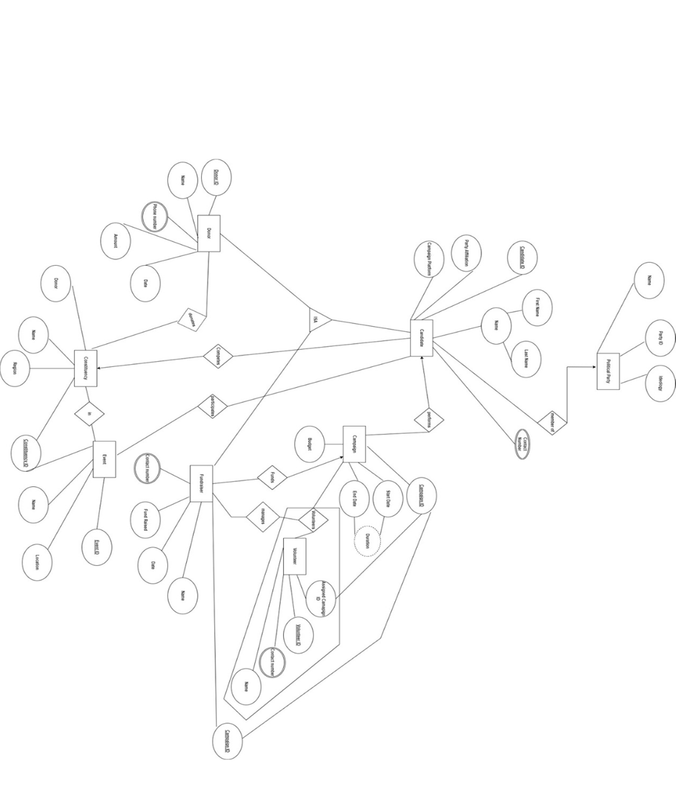

1.2.11.Entity – Relationship Model (ER Diagram)

1.3. Construction of Database

MySQL:

MySQL is a widely used open-source relational database management system (RDBMS) known for its reliability, scalability, and user-friendly nature. It's favored by developers for its ease of installation, configuration, and maintenance, making it accessible to both beginners and experienced database administrators. One of MySQL's key strengths lies in its scalability, allowing it to efficiently handle large volumes of data and high traffic loads, making it suitable for a wide range of applications, from small-scale websites to enterprise-level systems. Additionally, MySQL is optimized for performance, with features such as indexing, caching, and query optimization ensuring fast and efficient data retrieval and manipulation. MySQL is also highly compatible with various operating systems such as Linux, Windows, and macOS, as well as multiple programming languages, making it versatile and easy to integrate into existing software stacks. Furthermore, MySQL benefits from a large and active community of users and developers who contribute to its ongoing development, provide support, and share knowledge and best practices.

Apache NetBeans:

Apache NetBeans is an open-source integrated development environment (IDE) known for its versatility and comprehensive feature set. It supports multiple programming languages, including Java, JavaScript, HTML5, and PHP, making it suitable for a wide range of development tasks. Apache NetBeans provides developers with a rich set of tools and features, including code editors, debuggers, profilers, and version control integration, enhancing productivity and efficiency throughout the software development lifecycle. Its cross-platform nature allows developers to work seamlessly across different operating systems, further extending its accessibility.

One of the key advantages of Apache NetBeans is its extensibility. It features a modular architecture that enables developers to customize and extend its functionality through plugins and third-party extensions, catering to diverse development needs and preferences. Additionally, Apache NetBeans benefits from a vibrant community of developers and contributors who actively collaborate on its development, provide support, and contribute plugins and extensions to enhance its capabilities.

Apache Tomcat Server:

Apache Tomcat is an open-source web server and servlet container that is widely used for deploying and running Java-based web applications. It is known for its lightweight nature and scalability, making it suitable for hosting web applications with varying levels of traffic and complexity. As a servlet container, Apache Tomcat provides support for Java Servlet, JavaServer Pages (JSP), and Java Expression Language (EL), enabling developers to build dynamic and interactive web applications using Java technologies. Its scalability allows it to handle a large number of concurrent connections and requests efficiently.

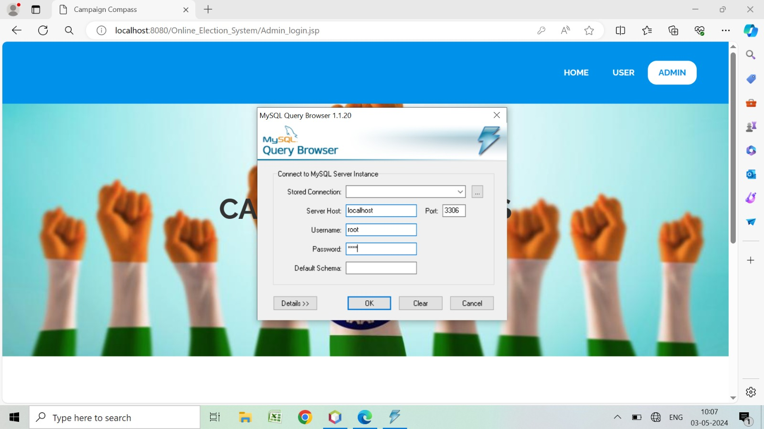

1.3.1. Login to the Database and connection

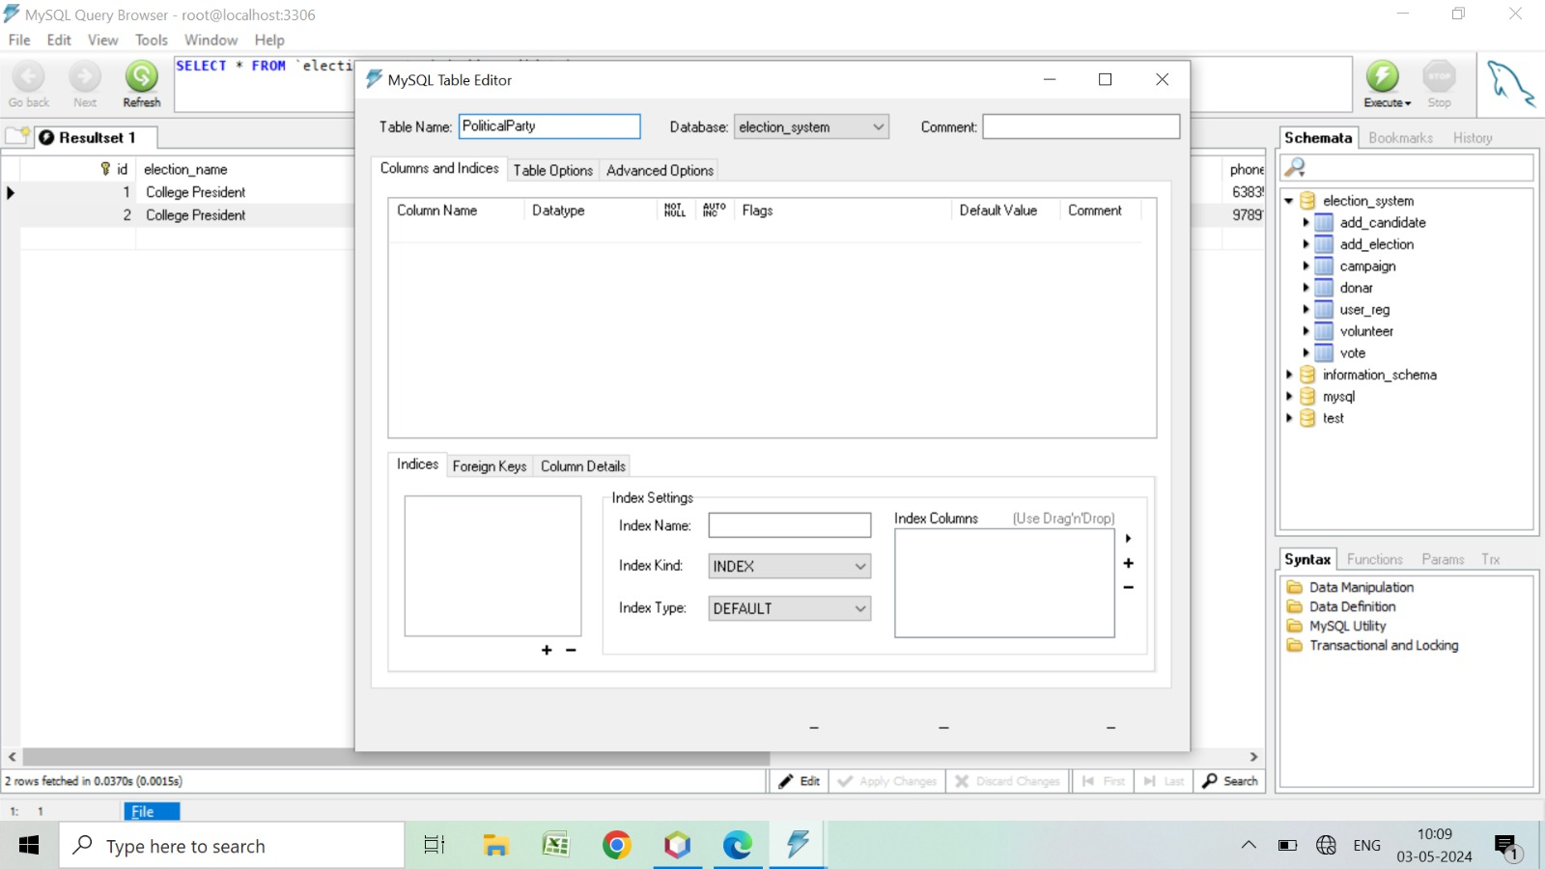

1.3.2. Creation of tables in Database, creating table Political Party

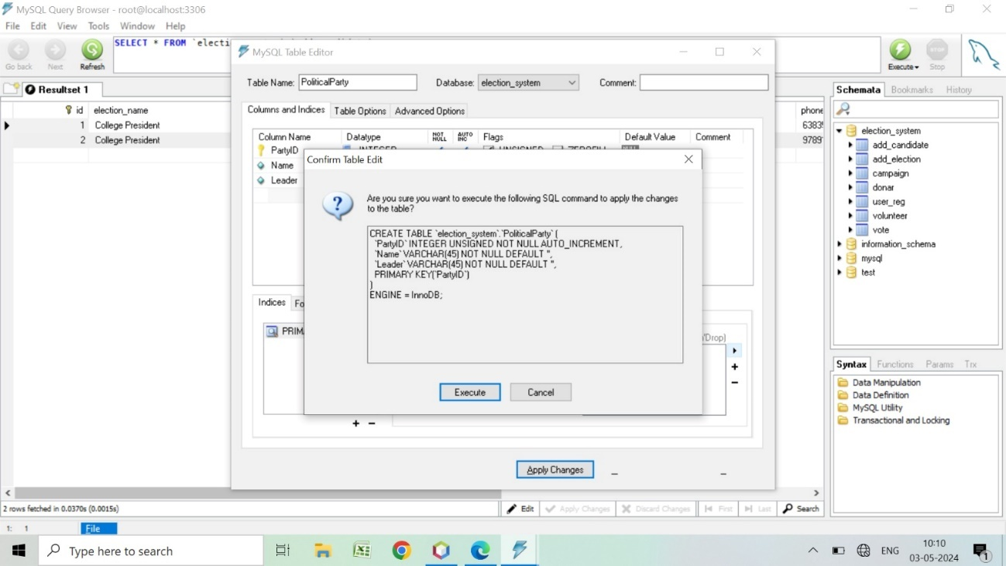

1.3.3. Table creation Query output

1. **DESIGN OF RELATIONAL SCHEMA**

The relational schema for the “VoteX – Campaign Compass” project outlines the structure of the database without delving into specific entities. It defines the relationships between different components of the system, facilitating efficient data management and retrieval. The schema includes primary keys to uniquely identify records, foreign keys to establish relationships between tables, and additional attributes to capture relevant information. By organizing the database in this manner, the schema serves as a foundational framework for the storage and organization of data, supporting the overarching objectives of the project to streamline political campaigning and voter engagement efforts.

The schema includes the following entities and attributes from Database:

The Election table is pivotal in organizing and managing electoral events. It meticulously logs crucial data like election dates, participating candidates, and constituency details. Each entry, identified by a unique ElectionID, represents a distinct electoral occurrence. By maintaining this structured repository, the Election table ensures transparency, accountability, and fairness in electoral processes.

User Registration acts as the initial gateway for individuals engaging in the electoral process. It catalogues pertinent information about registered users, encompassing personal details and contact information. Each entry denotes a registered voter or candidate, facilitating account management and communication. This table's accuracy and currency underpin the integrity and security of the electoral system, enabling seamless user interactions throughout the electoral cycle. The Voter table holds comprehensive records of registered voters, capturing their names, addresses, and contact particulars. Each entry, identified by a VoterID, represents an eligible voter. It serves as a cornerstone for election officials to verify voter eligibility, manage polling stations, and conduct outreach activities. The Voter table's accuracy and completeness uphold the fairness and legitimacy of the electoral process, ensuring every eligible voter can exercise their democratic right.

Containing vital data about individuals vying for political office, the Candidate table lists names, party affiliations, and campaign platforms. Each entry, identified by a CandidateID, represents a distinct candidate. This repository supports transparent and competitive elections by managing candidate registrations, tracking campaign activities, and enabling informed voter decisions. The Candidate table's integrity facilitates a robust democratic process, fostering public trust and engagement. The Campaign table serves as a hub for managing political campaigns associated with specific candidates or parties. It documents critical campaign details such as start and end dates, budgets, and descriptions. Each entry, denoted by a CampaignID, corresponds to a unique campaign event. This centralization facilitates effective planning, execution, and evaluation of campaign strategies, enhancing transparency and accountability in electoral campaigns.

The Donor table records contributions from individuals or organizations supporting political campaigns or parties. It catalogues donor names, contact information, donation amounts, and dates. Each transaction, identified by a DonorID, represents a unique donation. This repository plays a vital role in campaign finance management, ensuring compliance with regulations and promoting transparency in financial activities.

Containing details of individuals offering voluntary support to political campaigns or parties, the Volunteer table includes volunteer names and contact information. Each entry, identified by a VolunteerID, represents a dedicated volunteer. This repository streamlines volunteer recruitment, assignment, and coordination, amplifying campaign outreach and engagement efforts. The Political Party table houses information about political entities participating in the electoral process. It encompasses party names, leaders, and ideological affiliations. Each entry, identified by a PartyID, represents a distinct political party. This repository fosters transparency and informed decision-making by providing insights into party structures and platforms, enriching the democratic landscape.

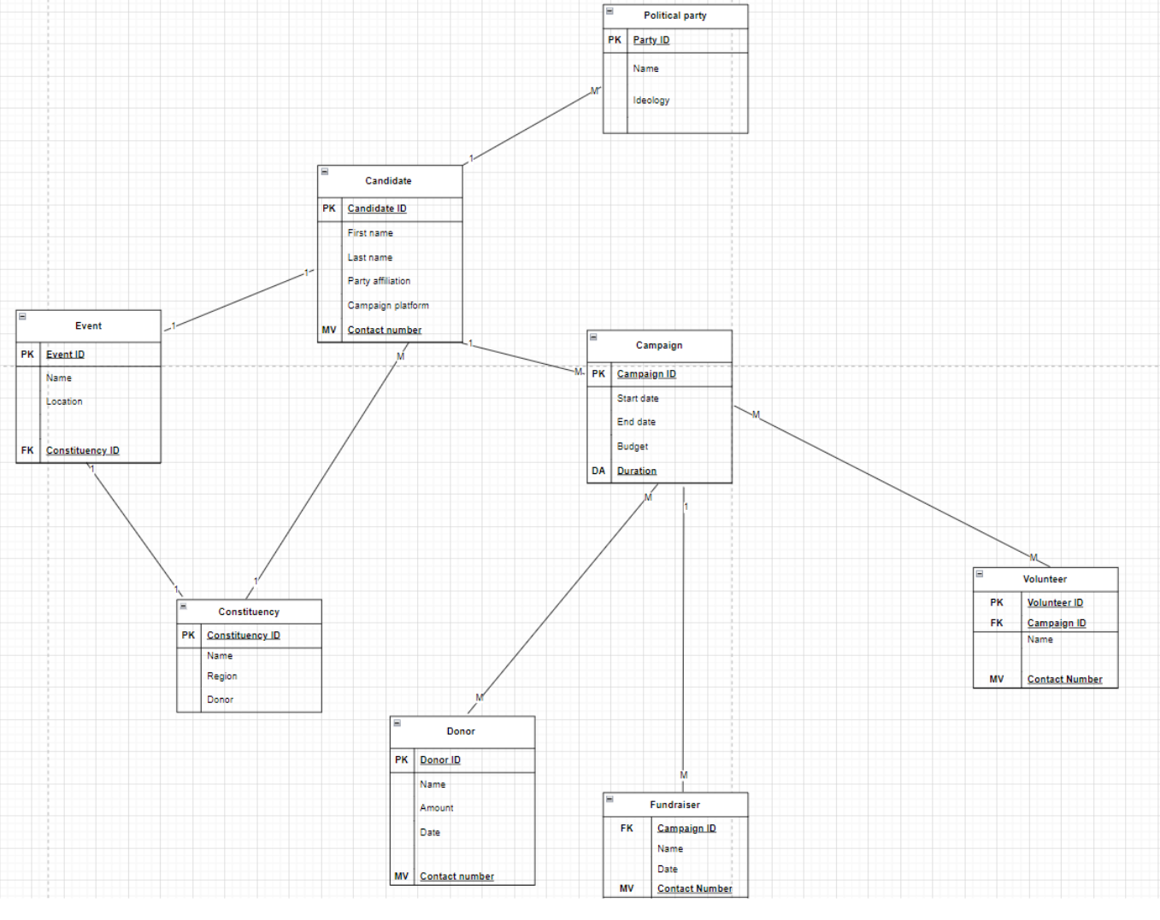

2.1(A) Relational Schema of our database

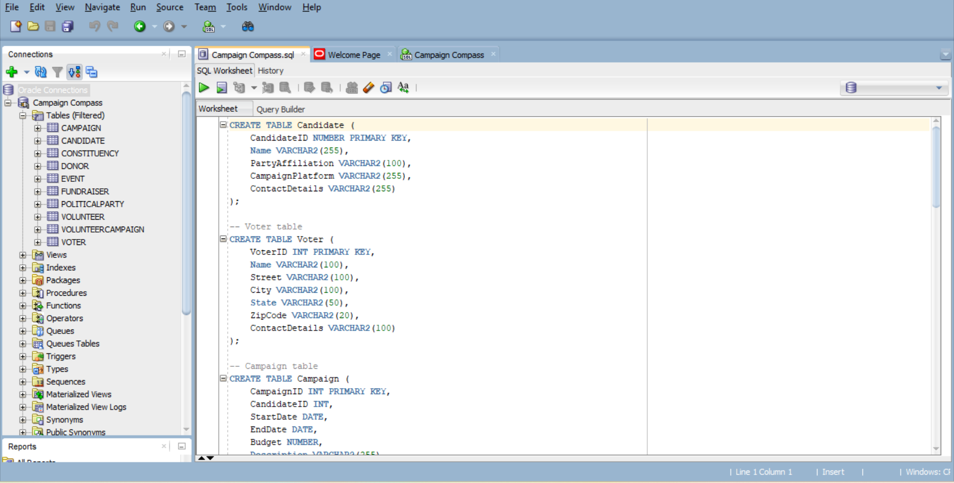

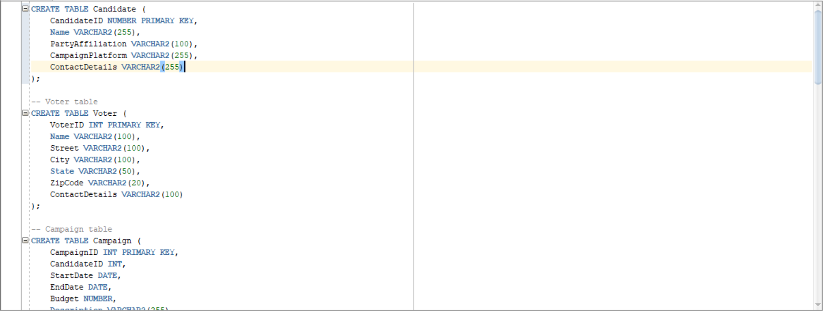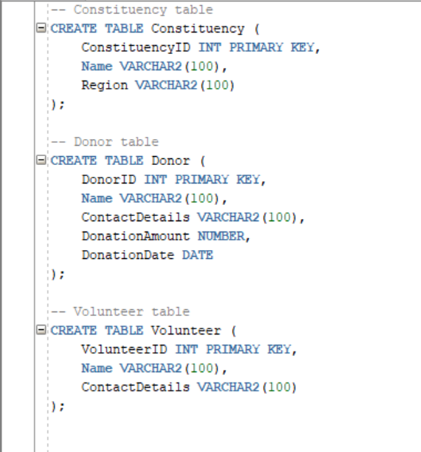

2.1.1.A general overview of the workbench in Oracle SQL after giving connection.

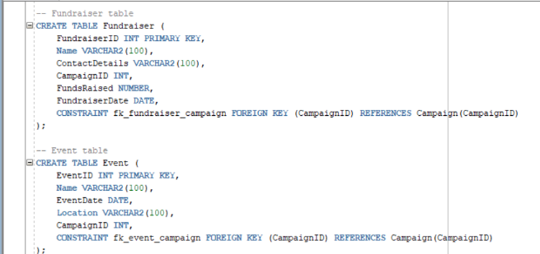

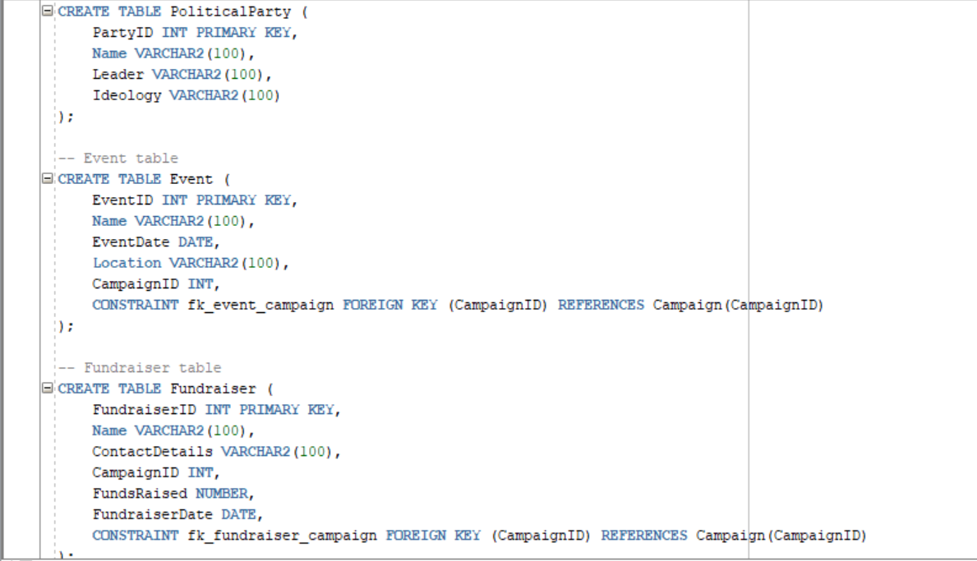

2.1.2. The DDL Commands for creating tables in the database along with the constraints.

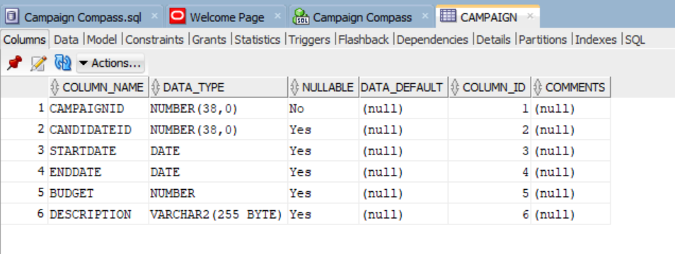

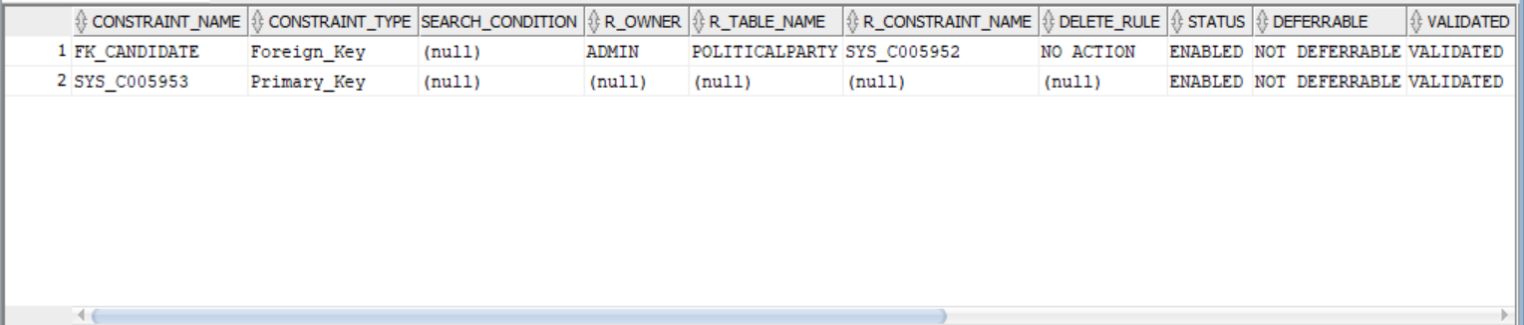

2.1.3. An example of a created table named “Campaign” with its attributes and constraints.

1. **COMPLEX QUERIES USING SQL**

3.1. Set Commands

SET Union – Retrieve the names of all voters and donors.

SELECT Name FROM Voter

UNION

SELECT Name FROM Donor;

Union All Retrieve the names of all voters and donors, including duplicates.

SELECT Name FROM Voter

UNION ALL

SELECT Name FROM Donor;

Intersect – Find the names of voters who are also donors.

SELECT Name FROM Voter

INTERSECT

SELECT Name FROM Donor;

Minus – Find the names of voters who are not donors.

SELECT Name FROM Voter

MINUS

SELECT Name FROM Donor;

Check if there are any donors who are also voters.

SELECT CandidateID, Name, PartyAffiliation

FROM Candidate outer

WHERE EXISTS

(SELECT 1

FROM Candidate inner

WHERE inner.CandidateID = outer.CandidateID

AND inner.Name <> outer.Name

AND inner.PartyAffiliation = outer.PartyAffiliation

AND inner.CampaignPlatform = outer.CampaignPlatform

AND inner.ContactDetails = outer.ContactDetails);

Not Exists --- Select candidate attributes where there does not exist another candidate with the same PartyAffiliation, CampaignPlatform, and ContactDetails but a different CandidateID

SELECT CandidateID, Name, PartyAffiliation, CampaignPlatform, ContactDetails

FROM Candidate outer

-- Check if there does not exist another candidate satisfying the specified conditions

WHERE NOT EXISTS)

-- Subquery to find candidates with the same PartyAffiliation, CampaignPlatform, and ContactDetails but a different CandidateID

SELECT 1

FROM Candidate inner

WHERE inner.PartyAffiliation = outer.PartyAffiliation

AND inner.CampaignPlatform = outer.CampaignPlatform

AND inner.ContactDetails = outer.ContactDetails

AND inner.CandidateID <> outer.CandidateID

In – Retrieve the names of donors who donated more than 5000 rupees.

SELECT Name FROM Donor WHERE DonationAmount > 5000;

Not In – Retrieve the names of donors who donated less than or equal to 5000 rupees.

SELECT Name FROM Donor WHERE DonationAmount <= 5000;

Except – Find the names of donors who are not also volunteers.

SELECT Name FROM Donor

EXCEPT

SELECT Name FROM Volunteer;

Distinct – Retrieve unique names of donors.

SELECT DISTINCT Name FROM Donor;

Union All of political party names and event names

SELECT Name FROM PoliticalParty

UNION ALL

SELECT Name FROM Event;

Except of fundraiser names and voter names

SELECT Name FROM Fundraiser

EXCEPT

SELECT Name FROM Voter;

Union of constituency names and polling station names

SELECT Name FROM Constituency

UNION

SELECT Name FROM PollingStation;

Intersection of event locations and polling station locations

SELECT Location FROM Event

INTERSECT

SELECT Location FROM PollingStation;

Union All of candidate names and volunteer names

SELECT Name FROM Candidate

UNION ALL

SELECT Name FROM Volunteer;

3.2. Join Commands

Join Campaign with Candidate to get Campaign details along with the Candidate’s name:

SELECT Campaign.*, Candidate.Name AS CandidateName

FROM Campaign

JOIN Candidate ON Campaign.CandidateID = Candidate.CandidateID;

Join Fundraiser with Campaign to get Fundraiser details along with the Campaign’s start and end dates:

SELECT Fundraiser.*, Campaign.StartDate, Campaign.EndDate

FROM Fundraiser

JOIN Campaign ON Fundraiser.CampaignID = Campaign.CampaignID;

Join Event with Campaign to get Event details along with the Campaign’s budget:

SELECT Event.*, Campaign.Budget

FROM Event

JOIN Campaign ON Event.CampaignID = Campaign.CampaignID;

Join Candidate with Constituency to get Candidate details along with the Constituency’s region:

SELECT Candidate.*, Constituency.Region

FROM Candidate

Join Fundraiser with Event to get Fundraiser details along with Event location and date:

SELECT Fundraiser.*, Event.Location, Event.EventDate

FROM Fundraiser

JOIN Event ON Fundraiser.CampaignID = Event.CampaignID;

Join Event with Political Party to get Event details along with Party’s name and ideology:

SELECT Event.*, PoliticalParty.Name AS PartyName, PoliticalParty.Ideology

FROM Event

3.3. View Commands

CREATE VIEW PollingStationDetailsView AS

SELECT PS.Name AS PollingStation_Name, PS.Location, PS.OpeningTime, PS.ClosingTime

FROM PollingStation PS;

CREATE VIEW CampaignDatesView AS

SELECT Description AS Campaign_Description, StartDate, EndDate

FROM Campaign;

CREATE VIEW ConstituencyRegionView AS

SELECT Name AS Constituency_Name, Region

FROM Constituency;

CREATE VIEW PoliticalPartyLeadersView AS

SELECT Name AS Party_Name, Leader

FROM PoliticalParty;

CREATE VIEW CandidatePartyView AS

SELECT Name AS Candidate_Name, PartyAffiliation

FROM Candidate;

CREATE VIEW EventLocationView AS

SELECT Name AS Event_Name, Location

FROM Event;

CREATE VIEW EventCampaignDescriptionView AS

SELECT E.Name AS Event_Name, C.Description AS Campaign_Description

FROM Event E

INNER JOIN Campaign C ON E.CampaignID = C.CampaignID;

CREATE VIEW PollingStationTimesView AS

SELECT Name AS PollingStation_Name, OpeningTime, ClosingTime

FROM PollingStation;

CREATE VIEW DonorContactDetailsView AS

SELECT Name AS Donor_Name, ContactDetails

FROM Donor;

3.4. Trigger Commands

CREATE OR REPLACE TRIGGER UpdateConstituencyRegion

BEFORE UPDATE OF Name ON Constituency

FOR EACH ROW

BEGIN

IF :OLD.Name <> :NEW.Name THEN

UPDATE Constituency SET Region = :NEW.Region WHERE ConstituencyID = :NEW.ConstituencyID;

END IF;

END;

/

CREATE OR REPLACE TRIGGER UpdateFundraiserDate

BEFORE INSERT ON Fundraiser

FOR EACH ROW

BEGIN

:NEW.FundraiserDate := SYSDATE;

END;

CREATE OR REPLACE TRIGGER CheckEventWeekend

BEFORE INSERT OR UPDATE ON Event

FOR EACH ROW

BEGIN

IF TO_CHAR(:NEW.EventDate, ‘D’) IN (1, 7) THEN

RAISE_APPLICATION_ERROR(-20008, ‘Events cannot be scheduled on weekends.’);

END IF;

END;

/

CREATE OR REPLACE TRIGGER UpdateOpeningTime

BEFORE UPDATE OF ClosingTime ON PollingStation

FOR EACH ROW

BEGIN

IF :OLD.ClosingTime <> :NEW.ClosingTime THEN

UPDATE PollingStation SET OpeningTime = :NEW.OpeningTime WHERE PollingStationID = :NEW.PollingStationID;

END IF;

END;

/

CREATE OR REPLACE TRIGGER DeleteAssociatedEvents

BEFORE DELETE ON Campaign

FOR EACH ROW

BEGIN

DELETE FROM Event WHERE Event.CampaignID = :OLD.CampaignID;

END;

/

CREATE OR REPLACE TRIGGER InsertDefaultLocation

BEFORE INSERT ON Event

FOR EACH ROW

BEGIN

IF :NEW.Location IS NULL THEN

:NEW.Location := ‘Default Event Location’;

END IF;

END;

/

3.5. Cursor Commands

-- Cursor to retrieve candidate names and their campaign platforms

DECLARE

CURSOR CandidateCursor IS

SELECT Name, CampaignPlatform

FROM Candidate;

BEGIN

-- Loop through each candidate record and output their name and campaign platform

FOR CandidateRec IN CandidateCursor LOOP

DBMS_OUTPUT.PUT_LINE(‘Candidate: ‘ || CandidateRec.Name || ‘, Campaign Platform: ‘ || CandidateRec.CampaignPlatform);

END LOOP;

END;

/

-- Cursor to calculate total funds raised by fundraisers

DECLARE

TotalFunds NUMBER := 0;

BEGIN

-- Loop through each fundraiser record and accumulate the total funds raised

FOR FundraiserRec IN (SELECT FundsRaised FROM Fundraiser) LOOP

TotalFunds := TotalFunds + FundraiserRec.FundsRaised;

END LOOP;

-- Output the total funds raised

DBMS_OUTPUT.PUT_LINE(‘Total Funds Raised: ‘ || TotalFunds);

END;

/

DECLARE

CURSOR VolunteerCursor IS

SELECT VolunteerID, Name, ContactDetails

FROM Volunteer;

BEGIN

-- Loop through each volunteer record and output its details

FOR VolunteerRec IN VolunteerCursor LOOP

DBMS_OUTPUT.PUT_LINE(‘Volunteer ID: ‘ || VolunteerRec.VolunteerID || ‘, Name: ‘ || VolunteerRec.Name || ‘, Contact Details: ‘ || VolunteerRec.ContactDetails);

END LOOP;

END;

/

-- Cursor to retrieve Fundraiser details

1. **NORMALIZATION**

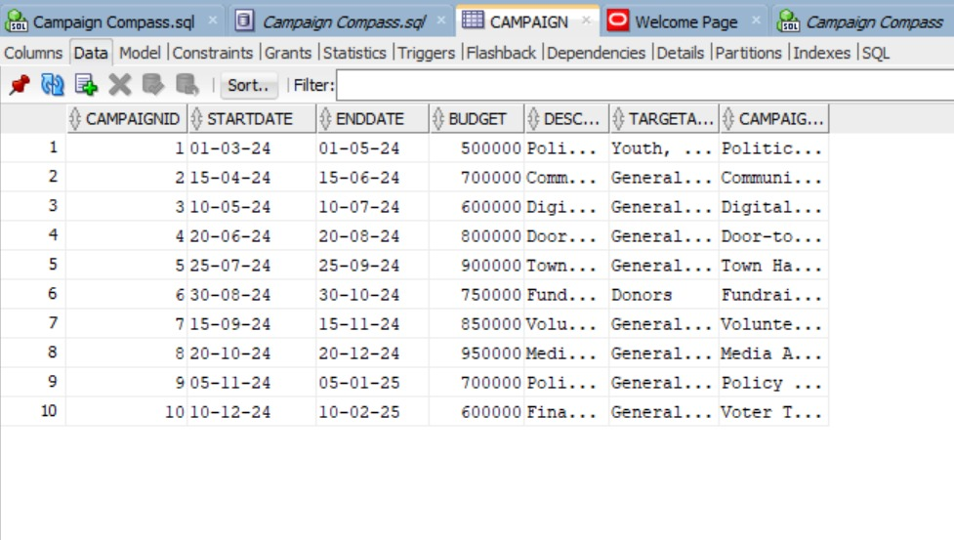

4.1.1 Campaign table

4.1. First Normal Form (1NF)

No multivalued attributes or repeating groups.

All attributes are atomic.

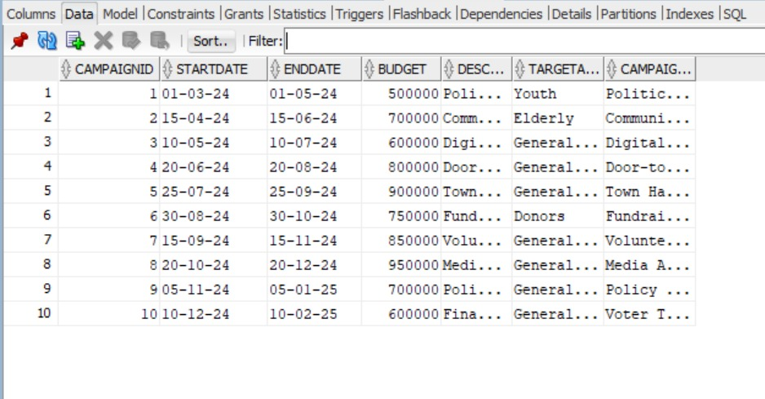

4.1.2 Atomicity

Functional Dependency:

(CampaignID, CampaignName) → StartDate, EndDate, Budget, Description, TargetAudience

Closure attributes:

{CampaignID, CampaignName}+ ={CampaignID, CampaignName, StartDate, EndDate, Budget, Description, TargetAudience}

Candidate Key: (CampaignID, CampaignName)

4.2.Second Normal Form (2NF)

Decomposed Relations:

R1(CampaignID, CampaignName, StartDate, EndDate, Budget, Description)

R2(CampaignID, CampaignName, TargetAudience)

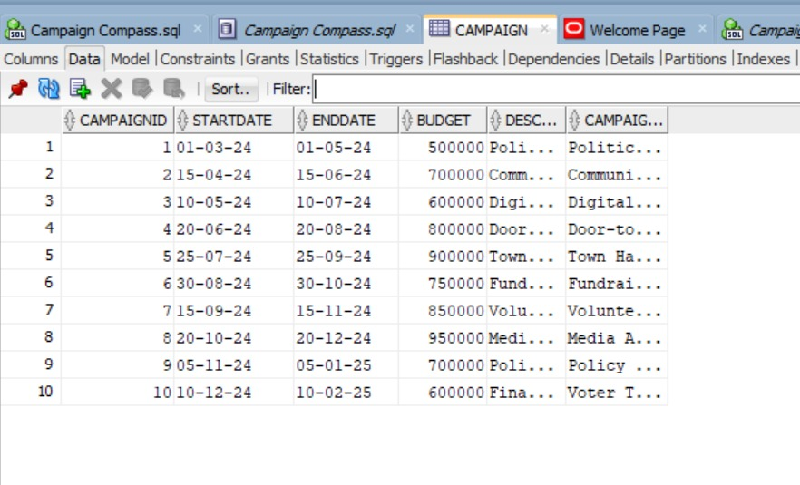

4.2.1. Relation R1

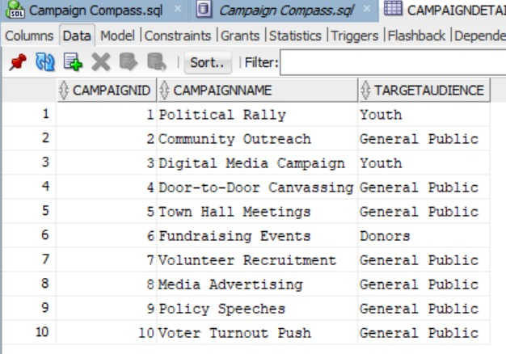

4.2.2. Relation R2

Functional Dependency:

CampaignID → CampaignName, StartDate, EndDate, Budget, Description

CampaignName → TargetAudience

Closure attributes:

{CampaignID, CampaignName}+ ={CampaignID, CampaignName, StartDate, EndDate, Budget, Description}

Candidate keys:{CampaignID,CampaignName}

4.3. Third Normal Form:

considering this table which satisfied 2NF,



4.3.1 Considering the table from 2NF

Functional Dependency:

CampaignID, CampaignName → StartDate, EndDate, Budget, Description

StartDate → EndDate

CampaingID -> Enddate

Decomposing the table :

R1(CampaignID, CampaignName, StartDate, Budget, Description)

R2(StartDate, EndDate)

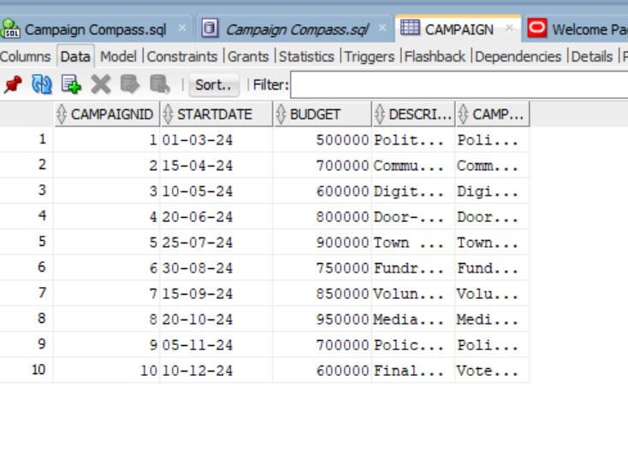

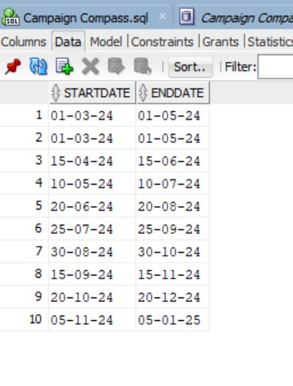

4.3.2. Relation 1 & 2

Candidate Key:

{CampaignID,CampaignName}

Closure Attributes

{CampaignID, CampaignName}+ ={CampaignID, CampaignName, StartDate, Budget, Description}

{StartDate}+ ={StartDate, EndDate}

4.4. BCNF

Functional dependency:

CampaignID, CampaignName → StartDate, Budget, Description

Closure:

{CampaignID}+ ={CampaignID, StartDate, Budget, Description}

{CampaignID, CampaignName}+ ={CampaignID, CampaignName}

super keys:{CampaignID, CampaignName}

Consider this table,



4.4.1. Table unchanged after identifying the super key BCNF

The table has super key CampaignID so it need not to be divided further decomposed it has already satisfies BCNF.

4.5. Fourth Normal Form(4NF)

,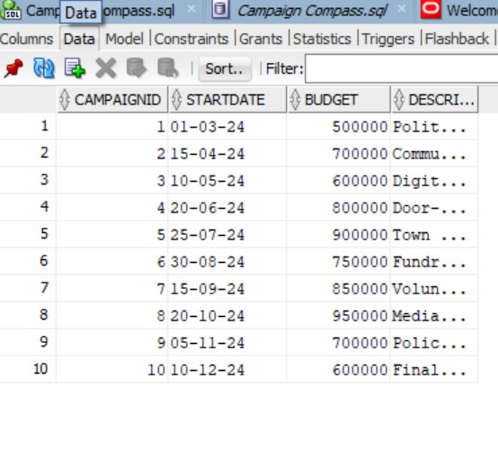

4.5.1. Table satisfied 3NF

MVD: {CampaignID} ->> {StartDate}

Functional Dependency:

CampaignID -> (StartDate, Budget, Description)

Candidate Key: {CampaignID}

Closure Attributes: {CampaignID}+ = {CampaignID, StartDate, Budget, Description

Decomposing the table

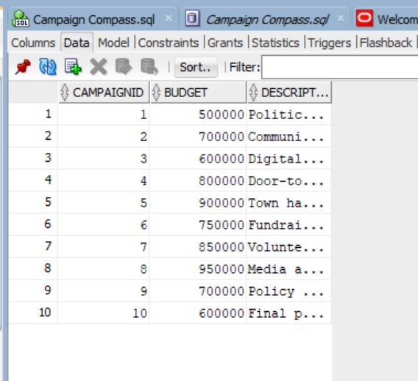

4.5.2 R1(CampaignID, Budget, Description)

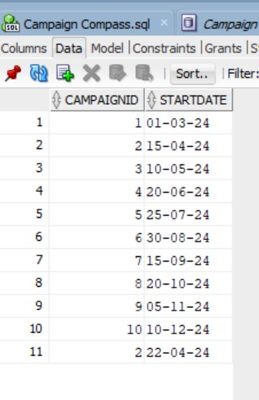

4.5.3. R2(CampaignID, StartDate)

4.6. Fifth Normal Form 5NF



4.6.1 Table satisfying 4NF

Functional Dependency:

CampaignID -> Budget, Description

Candidate Key: {CampaignID}

Closure Attributes: {CampaignID}+ = {CampaignID, Budget, Description}

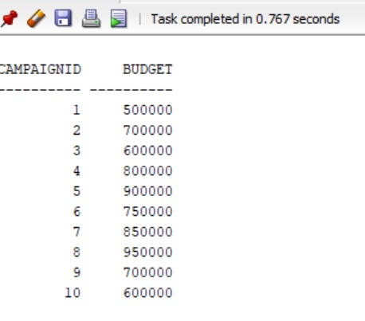

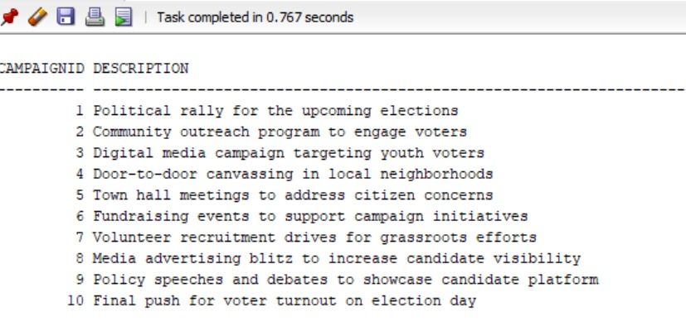

4.6.2. Tables satisfying 5NF and they cannot be divided further

**5. TRANSACTION CONTROLS AND CONCURRENCY TECHNIQUES**

Transaction controls and concurrency techniques are crucial aspects of database management systems (DBMS) and play a vital role in ensuring data integrity, consistency, and isolation of our VoteX database.

5.1. Candidate

DECLARE

-- Transaction 1: Inserting a new candidate

v_candidate_id_1 VARCHAR2(50) := ‘1’;

v_name_1 VARCHAR2(100) := ‘Alice Johnson’;

v_party_affiliation_1 VARCHAR2(100) := ‘Progressive Alliance’;

v_campaign_platform_1 VARCHAR2(100) := ‘Education Reform’;

v_contact_details_1 VARCHAR2(100) := ‘alice@example.com’;

BEGIN

-- Attempt to insert a new candidate record into the Candidate table for transaction 1

-- Placeholder for inserting a new candidate record into the Candidate table

-- INSERT INTO Candidate (CandidateID, Name, PartyAffiliation, CampaignPlatform, ContactDetails) COMMIT;

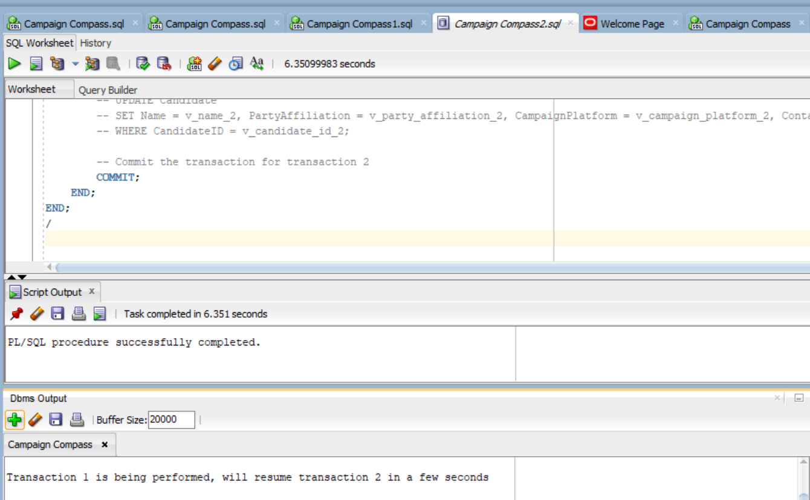

5.1.1. Result of the query in Oracle SQL for table Candidate

Transaction 1:

* Attempt to insert a new candidate record into the Candidate table.
* Print a message indicating transaction 1 is being performed.
* Commit the transaction for transaction 1.

Transaction 2:

* Introduce a delay of 5 seconds between transactions to allow for the completion of the first transaction.
* Update an existing candidate record in the Candidate table for transaction 2.
* Commit the transaction for transaction 2.

5.2. Campaign

DECLARE

-- Transaction 1: Inserting a new campaign

v_campaign_id_1 VARCHAR2(50) := ‘1’;

v_candidate_id_1 VARCHAR2(50) := ‘1’;

v_start_date_1 DATE := TO_DATE(‘2024-04-01’, ‘YYYY-MM-DD’);

v_end_date_1 DATE := TO_DATE(‘2024-04-30’, ‘YYYY-MM-DD’);

v_budget_1 NUMBER := 10000;

v_description_1 VARCHAR2(200) := ‘Education Reform Campaign’;

BEGIN

-- Attempt to insert a new campaign record into the Campaign table for transaction 1

-- Placeholder for inserting a new campaign record into the Campaign table

-- INSERT INTO Campaign (CampaignID, CandidateID, StartDate, EndDate, Budget, Description)

-- VALUES (v_campaign_id_1, v_candidate_id_1, v_start_date_1, v_end_date_1, v_budget_1, v_description_1);

-- Print a message indicating transaction 1 is being performed

DBMS_OUTPUT.PUT_LINE(‘Transaction 1 is being performed, will resume transaction 2 in a few seconds’);

-- Commit the transaction for transaction 1

COMMIT;

-- Introduce a delay between transactions

-- This can be adjusted as needed

DBMS_LOCK.sleep(5); -- Sleep for 5 seconds

-- Transaction 2: Updating an existing campaign

DECLARE

v_campaign_id_2 VARCHAR2(50) := ‘2’;

v_end_date_2 DATE := TO_DATE(‘2024-05-15’, ‘YYYY-MM-DD’);

v_budget_2 NUMBER := 15000;

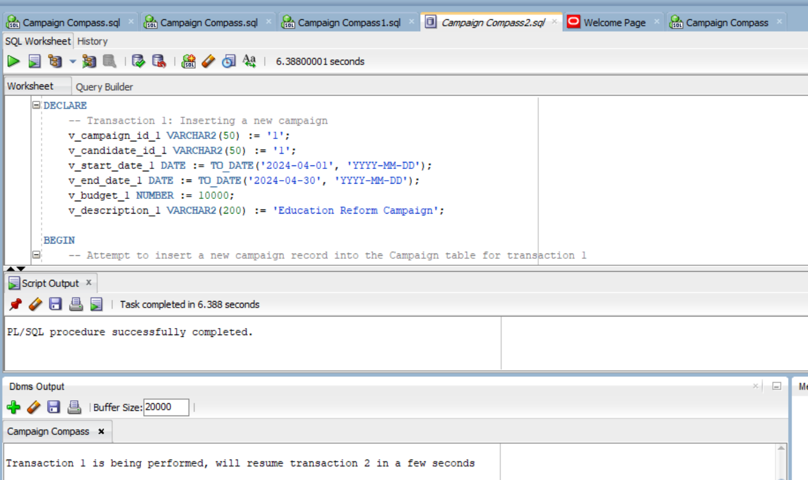

5.2.1. Result of the query in Oracle SQL for table Campaign

Transaction 1:

* Attempt to insert a new campaign record into the Campaign table.
* Print a message indicating transaction 1 is being performed.
* Commit the transaction for transaction 1.

Transaction 2:

* Introduce a delay of 5 seconds between transactions to allow for the completion of the first transaction.
* Update an existing campaign record in the Campaign table for transaction 2.
* Commit the transaction for transaction 2.

5.3. Political party

DECLARE

-- Define variables for the new political party

v_party_id VARCHAR2(50) := ‘1’;

v_name VARCHAR2(100) := ‘Progressive Alliance’;

v_leader VARCHAR2(100) := ‘Emily Johnson’;

v_ideology VARCHAR2(100) := ‘Progressivism’;

v_contact_details VARCHAR2(100) := ‘info@progressivealliance.com’;

BEGIN

-- Insert a new political party record into the Political Party table

-- Placeholder for inserting a new record into the Political Party table

-- INSERT INTO PoliticalParty (PartyID, Name, Leader, Ideology, ContactDetails)

-- VALUES (v_party_id, v_name, v_leader, v_ideology, v_contact_details);

-- Print a message indicating the successful insertion of the political party record

DBMS_OUTPUT.PUT_LINE(‘Political Party record inserted successfully.’);

END;

/

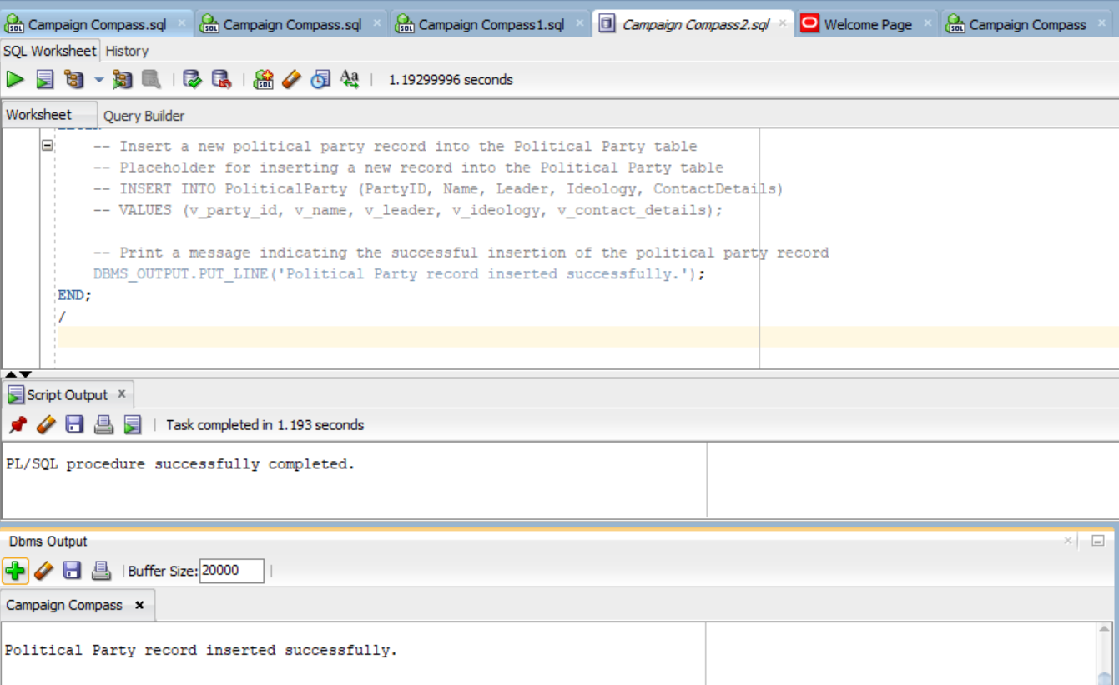

5.3.1. Result of the query in Oracle SQL for table Political Party

Transaction:

* Insert a new record into the Political Party table with the provided attribute values.
* Print a message indicating the successful insertion of the political party record using DBMS_OUTPUT.PUT_LINE. This message will be displayed in the Oracle database environment.

5.4. Event

DECLARE

-- Transaction 1: Inserting a new event

v_event_id_1 VARCHAR2(50) := ‘1’;

v_name_1 VARCHAR2(100) := ‘Fundraising Concert’;

v_event_date_1 DATE := SYSDATE;

v_location_1 VARCHAR2(100) := ‘Concert Hall’;

v_campaign_id_1 VARCHAR2(50) := ‘1’;

-- Define a lock variable

v_lock NUMBER;

-- Define a variable to store the result of lock attempt

v_lock_result NUMBER;

BEGIN

-- Attempt to acquire an exclusive lock on a row in the Event table for transaction 1

BEGIN

SELECT 1 INTO v_lock_result FROM dual WHERE NOT EXISTS (SELECT 1 FROM Event WHERE EventID = v_event_id_1) FOR UPDATE NOWAIT;

EXCEPTION

WHEN NO_DATA_FOUND THEN

-- Handle the case when no row is found to lock

v_lock_result := 0;

END;

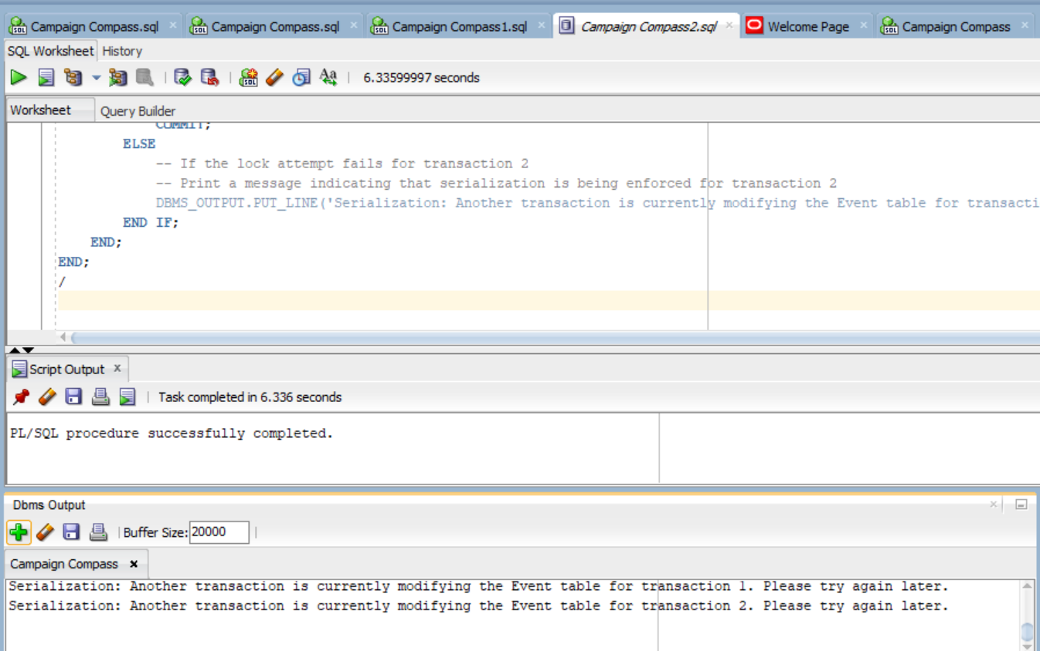

5.4.1. Result of the query in Oracle SQL for table Event

5.5. Fundraiser

DECLARE

-- Define variables for the fundraiser transaction

v_fundraiser_id VARCHAR2(50) := ‘1’;

v_name VARCHAR2(100) := ‘Charity Gala’;

v_contact_details VARCHAR2(100) := ‘gala@example.com’;

v_campaign_id VARCHAR2(50) := ‘1’;

v_funds_raised NUMBER := 5000;

v_fundraiser_date DATE := SYSDATE;

-- Define a lock variable

v_lock NUMBER;

-- Define a variable to store the result of lock attempt

v_lock_result NUMBER;

-- Print a message indicating the fundraiser transaction is being performed

DBMS_OUTPUT.PUT_LINE(‘Fundraiser transaction is being performed’);

-- Commit the transaction to release the lock

COMMIT;

ELSE

-- If the lock attempt fails (i.e., another transaction is holding the lock)

-- Print a message indicating that serialization is being enforced

DBMS_OUTPUT.PUT_LINE(‘Serialization: Another transaction is currently modifying the Fundraiser table. Please try again later.’);

END IF;

END;

/

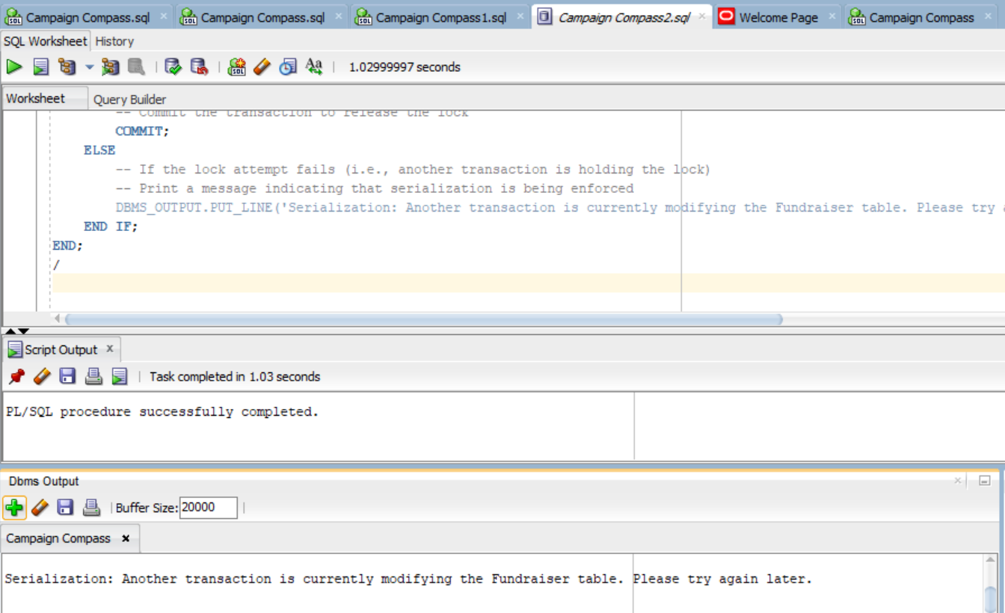

5.5.1. Result of the query in Oracle SQL for table Fundraiser

5.6. Volunteer

DECLARE

v_volunteer_id_1 VARCHAR2(50) := ‘1’;

v_name_1 VARCHAR2(100) := ‘Alice Smith’;

v_contact_details_1 VARCHAR2(100) := ‘alice@example.com’;

-- Define a lock variable

v_lock NUMBER;

-- Define a variable to store the result of lock attempt

v_lock_result NUMBER;

BEGIN

-- Transaction 1 (Inserting a Volunteer)

-- Attempt to acquire an exclusive lock on a row in the Volunteer table

BEGIN

SELECT 1 INTO v_lock_result FROM dual WHERE NOT EXISTS (SELECT 1 FROM Volunteer WHERE VolunteerID = v_volunteer_id_1) FOR UPDATE NOWAIT;

EXCEPTION

WHEN NO_DATA_FOUND THEN

-- Handle the case when no row is found to lock

v_lock_result := 0;

END;

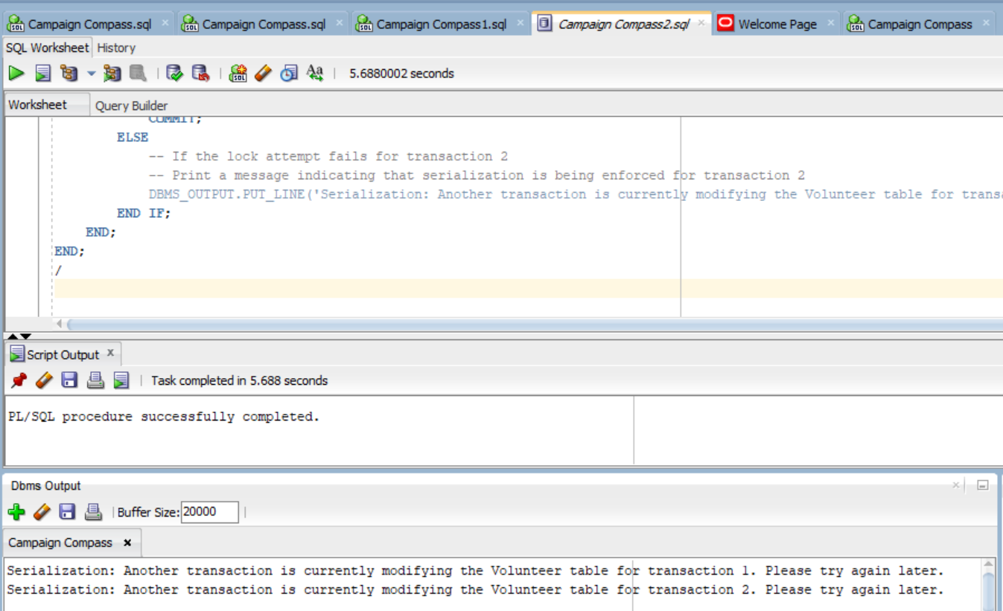

5.6. Result of the query in Oracle SQL for table Volunteer

Transaction:

* Transaction 1 attempts to insert a new volunteer record into the Volunteer table. If successful, it prints a message indicating that transaction 1 is being performed.
* After a delay of 5 seconds, transaction 2 attempts to update an existing volunteer record in the Volunteer table (for demonstration purposes). If successful, it prints a message indicating that transaction 2 is being performed.
* If either transaction fails due to serialization (i.e., another transaction is currently modifying the table), an appropriate message is displayed.

5.7. Donor

DECLARE

v_donor_id_1 VARCHAR2(50) := ‘1’;

v_name_1 VARCHAR2(100) := ‘John Doe’;

v_contact_details_1 VARCHAR2(100) := ‘john@example.com’;

v_donation_amount_1 NUMBER := 1000;

v_donation_date_1 DATE := SYSDATE;

-- Define a lock variable

v_lock NUMBER;

-- Define a variable to store the result of lock attempt

v_lock_result NUMBER;

BEGIN

-- Transaction 1 (Inserting a Donor)

-- Attempt to acquire an exclusive lock on a row in the Donor table

BEGIN

SELECT 1 INTO v_lock_result FROM dual WHERE NOT EXISTS (SELECT 1 FROM Donor WHERE DonorID = v_donor_id_1) FOR UPDATE NOWAIT;

EXCEPTION

WHEN NO_DATA_FOUND THEN

-- Handle the case when no row is found to lock

v_lock_result := 0;

END;

DBMS_OUTPUT.PUT_LINE(‘Serialization: Another transaction is currently modifying the Donor table for transaction 1. Please try again later.’);

END IF;

-- Introduce a delay between transactions

-- This can be adjusted as needed

DBMS_LOCK.sleep(5); -- Sleep for 5 seconds

-- Transaction 2 (Updating a Donor)

-- Update an existing Donor (for demonstration purposes)

DECLARE

v_donor_id_2 VARCHAR2(50) := ‘2’;

v_name_2 VARCHAR2(100) := ‘Jane Smith’;

v_contact_details_2 VARCHAR2(100) := ‘jane@example.com’;

v_donation_amount_2 NUMBER := 1500;

v_donation_date_2 DATE := SYSDATE;

BEGIN

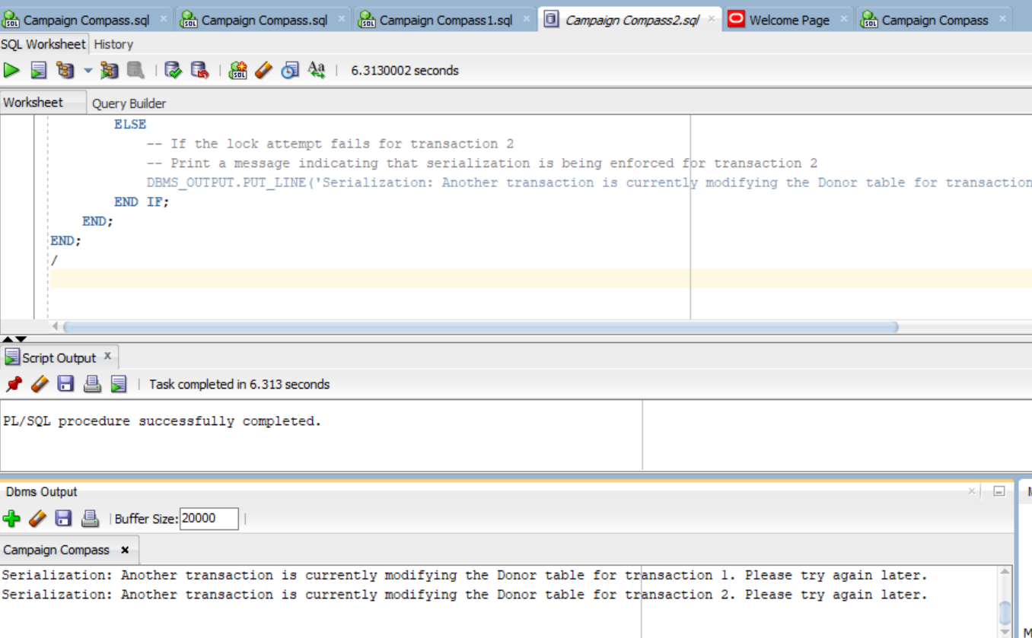

5.7.1. Result of the query in Oracle SQL for table Donor.

Transaction:

* Transaction 1 attempts to insert a new volunteer record into the Donor table. If successful, it prints a message indicating that transaction 1 is being performed.
* After a delay of 5 seconds, transaction 2 attempts to update an existing Donor record in the donor table (for demonstration purposes). If successful, it prints a message indicating that transaction 2 is being performed.
* If either transaction fails due to serialization (i.e., another transaction is currently modifying the table), an appropriate message is displayed.

5.8. Constituency

DECLARE

v_constituency_id_1 VARCHAR2(50) := ‘1’;

v_name_1 VARCHAR2(100) := ‘ABC Constituency’;

v_region_1 VARCHAR2(100) := ‘North’;

-- Transaction 1 (Inserting a Constituency)

-- Attempt to acquire an exclusive lock on a row in the Constituency table

BEGIN

SELECT 1 INTO v_lock_result FROM dual WHERE NOT EXISTS (SELECT 1 FROM Constituency WHERE ConstituencyID = v_constituency_id_1) FOR UPDATE NOWAIT;

EXCEPTION

WHEN NO_DATA_FOUND THEN

-- Handle the case when no row is found to lock

v_lock_result := 0;

END;

-- Introduce a delay between transactions

-- This can be adjusted as needed

DBMS_LOCK.sleep(5); -- Sleep for 5 seconds

-- Transaction 2 (Updating a Constituency)

-- Update an existing Constituency (for demonstration purposes)

DECLARE/

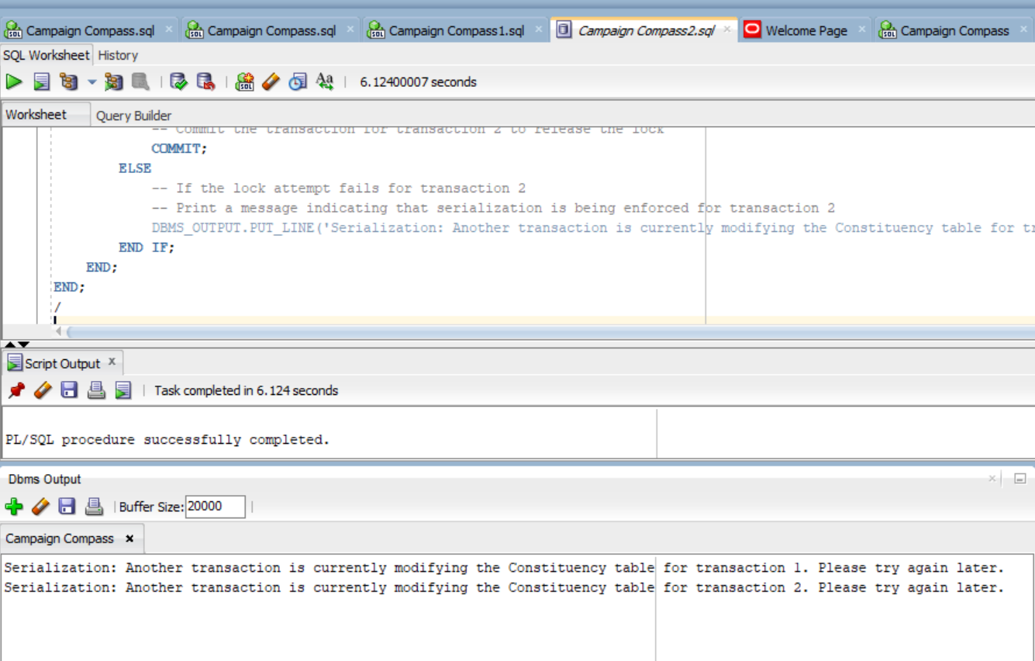

5.8.1. Result of the query in Oracle SQL for table Constituency.

Transaction:

* Transaction 1 attempts to insert a new volunteer record into the constituency table. If successful, it prints a message indicating that transaction 1 is being performed.
* After a delay of 5 seconds, transaction 2 attempts to update an existing constituency record in the constituency table (for demonstration purposes). If successful, it prints a message indicating that transaction 2 is being performed.
* If either transaction fails due to serialization (i.e., another transaction is currently modifying the table), an appropriate message is displayed.

5.9. Polling station

DECLARE

v_polling_station_id_1 VARCHAR2(50) := ‘1’;

v_name_1 VARCHAR2(100) := ‘Main Street Polling Station’;

v_location_1 VARCHAR2(100) := ‘Main Street’;

v_opening_time_1 VARCHAR2(100) := ‘08:00 AM’;

v_closing_time_1 VARCHAR2(100) := ‘06:00 PM’;

v_contact_details_1 VARCHAR2(100) := ‘mainstreet@example.com’;

v_constituency_id_1 VARCHAR2(50) := ‘1’ ; v_lock_result := 0;

END;

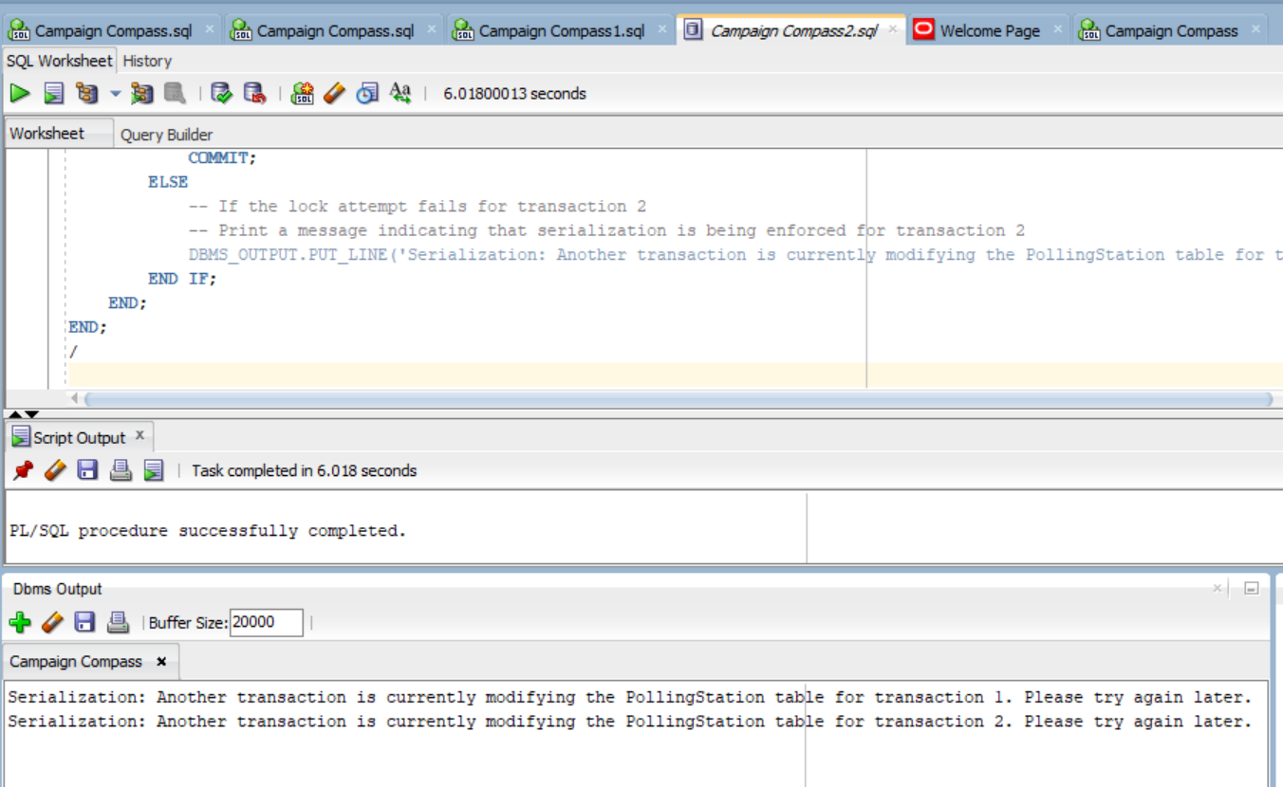

5.9.1. Result of the query in Oracle SQL for table Polling station

Transaction:

* Transaction 1 attempts to insert a new volunteer record into the Polling Station table. If successful, it prints a message indicating that transaction 1 is being performed.
* After a delay of 5 seconds, transaction 2 attempts to update an existing Polling Station record in the Polling Station table (for demonstration purposes). If successful, it prints a message indicating that transaction 2 is being performed.
* If either transaction fails due to serialization (i.e., another transaction is currently modifying the table), an appropriate message is displayed.

5.10. Voter

DECLARE

v_voter_id_1 VARCHAR2(50) := ‘1’;

v_name_1 VARCHAR2(100) := ‘Suresh Sharma’;

v_street_1 VARCHAR2(100) := ‘123 Gandhi Road’;

v_city_1 VARCHAR2(100) := ‘Delhi’;

v_state_1 VARCHAR2(100) := ‘Delhi’;

v_zipcode_1 VARCHAR2(10) := ‘110001’;

v_contact_details_1 VARCHAR2(100) := ‘suresh.sharma@example.com’;

END;

-- If the lock attempt succeeds

-- Commit the transaction to release the lock

COMMIT;

ELSE

-- If the lock attempt fails (i.e., another transaction is holding the lock)

-- Print a message indicating that serialization is being enforced

DBMS_OUTPUT.PUT_LINE(‘Serialization: Another transaction is currently modifying the Voter table. Please try again later.’);

END IF;

-- Introduce a delay between transactions

-- This can be adjusted as needed

DBMS_LOCK.sleep(5); -- Sleep for 5 seconds

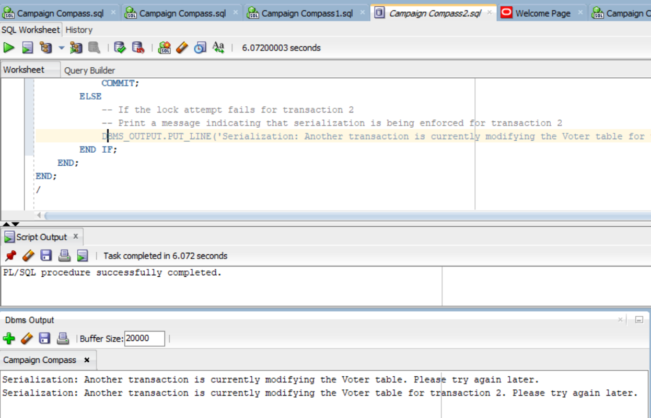

5.10.1. Result of the query in Oracle SQL for table Voter.

**6. IMPLEMENTATION**

**6.1. User Panel**

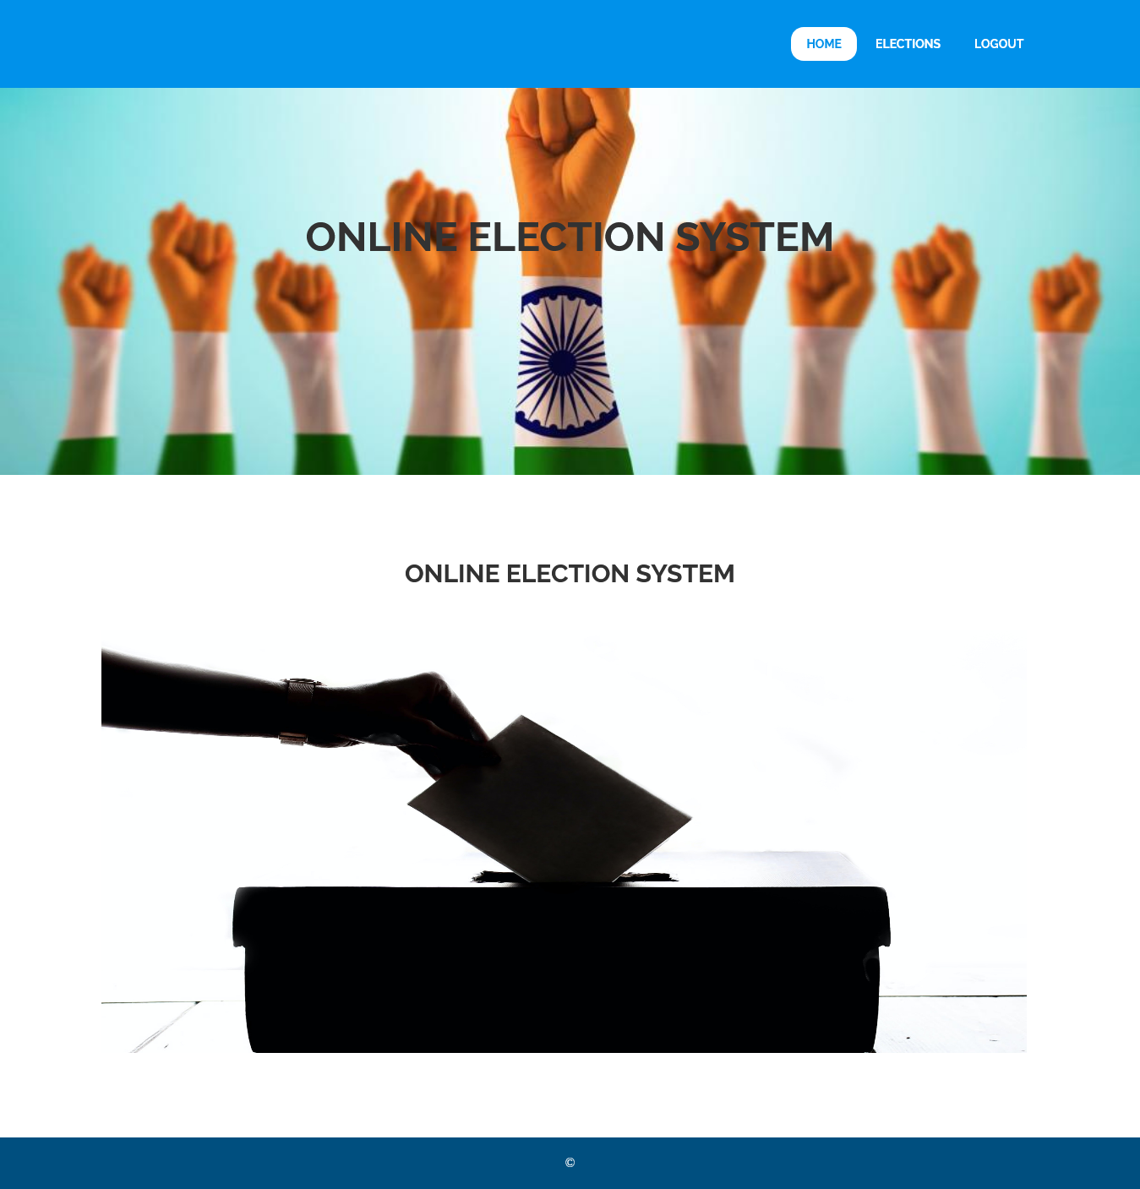

6.1.1. Welcome page

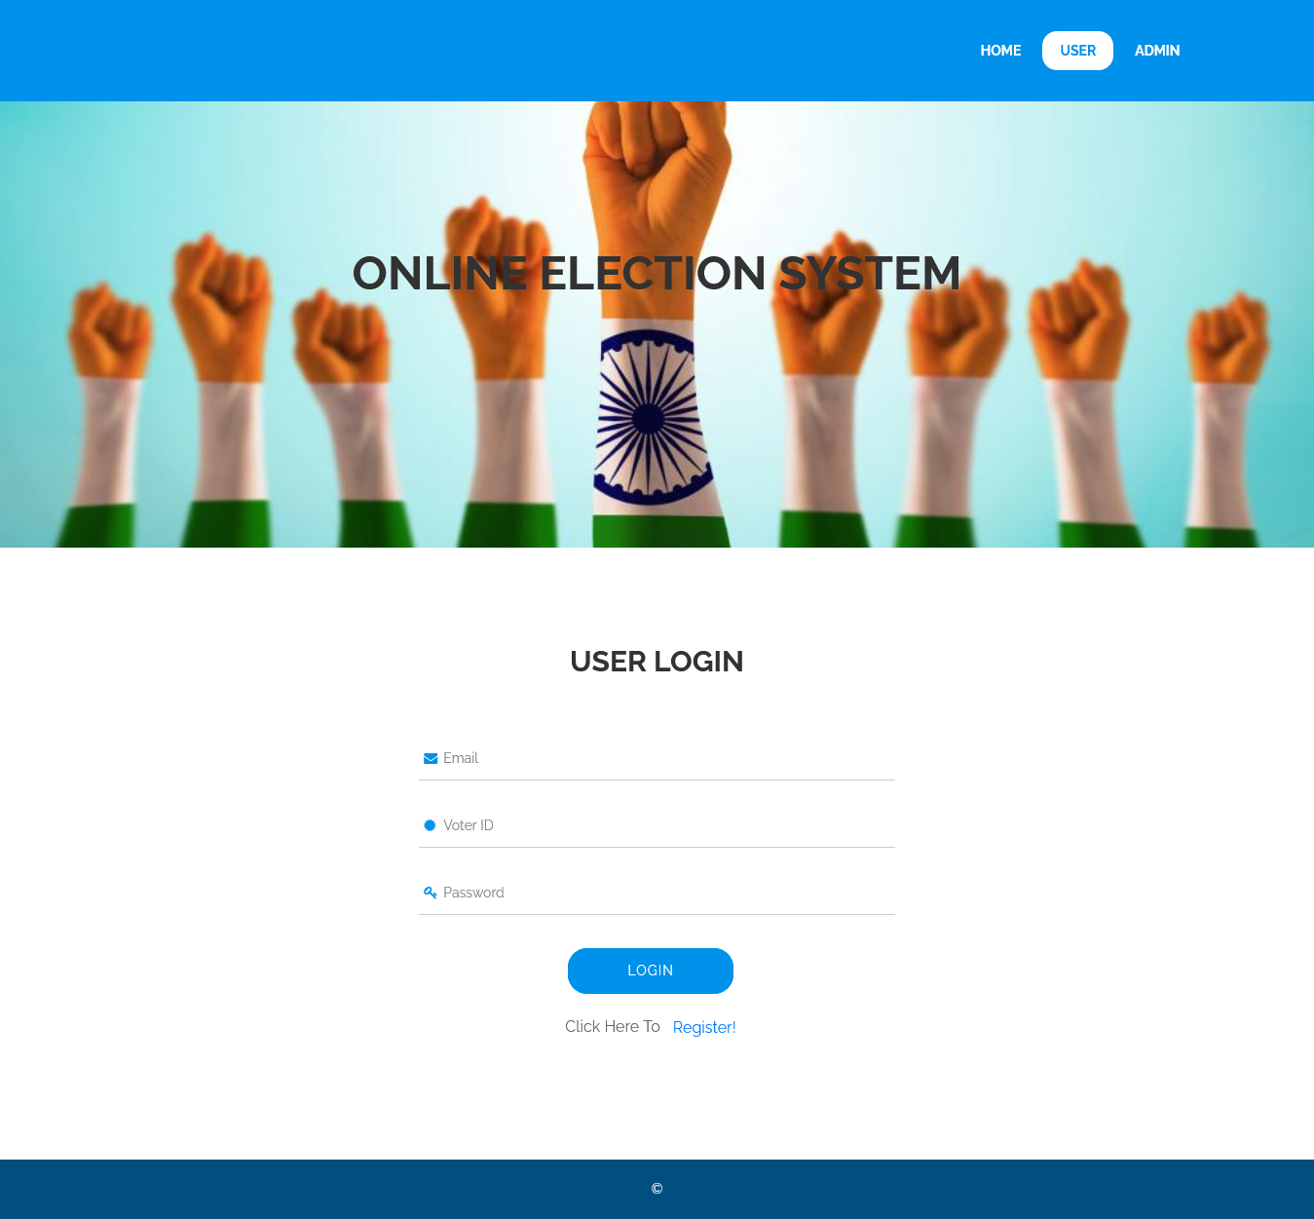

6.1.2. User Login Page

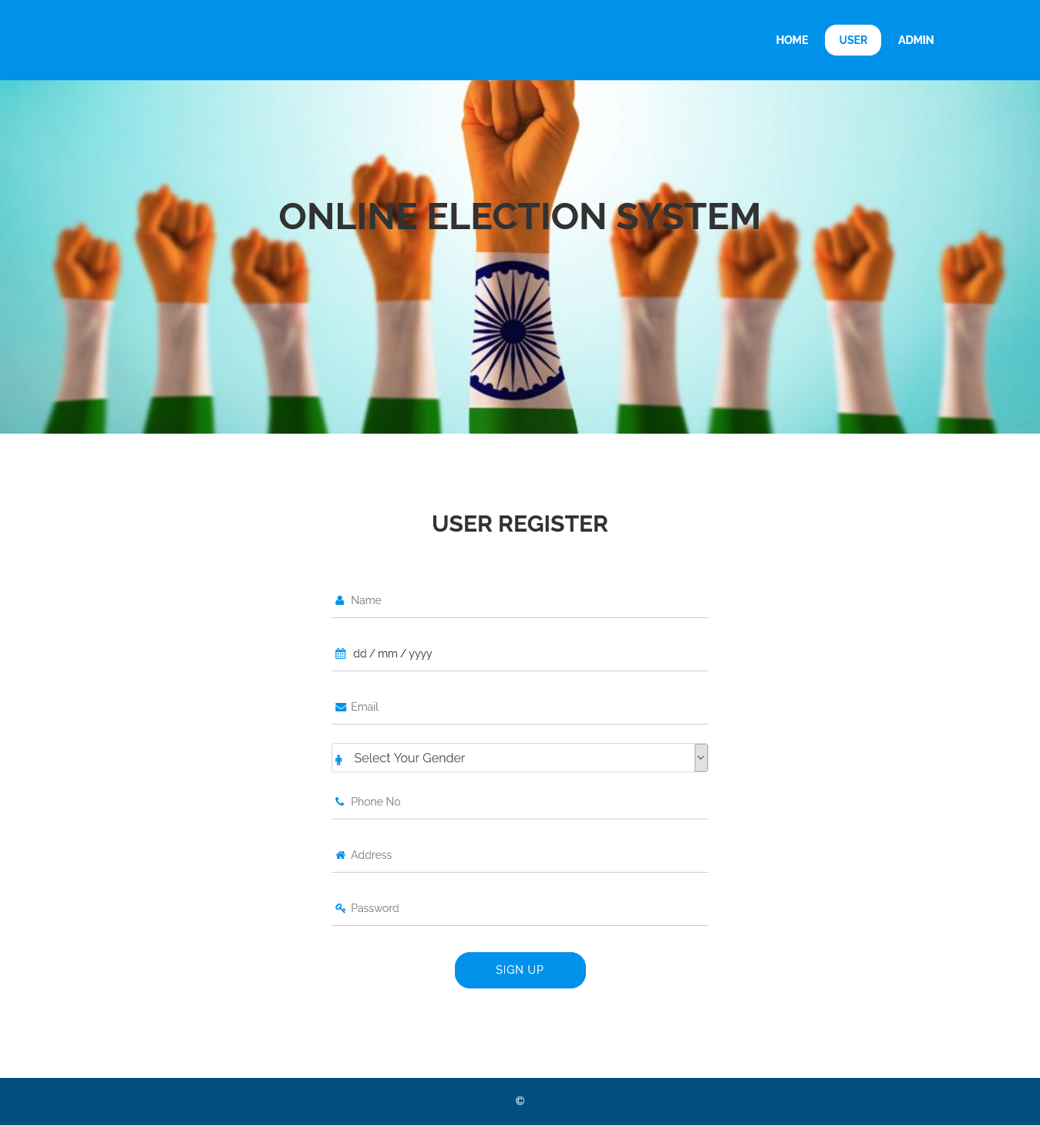

6.2.2. New User Registration page

6.2. Admin Panel

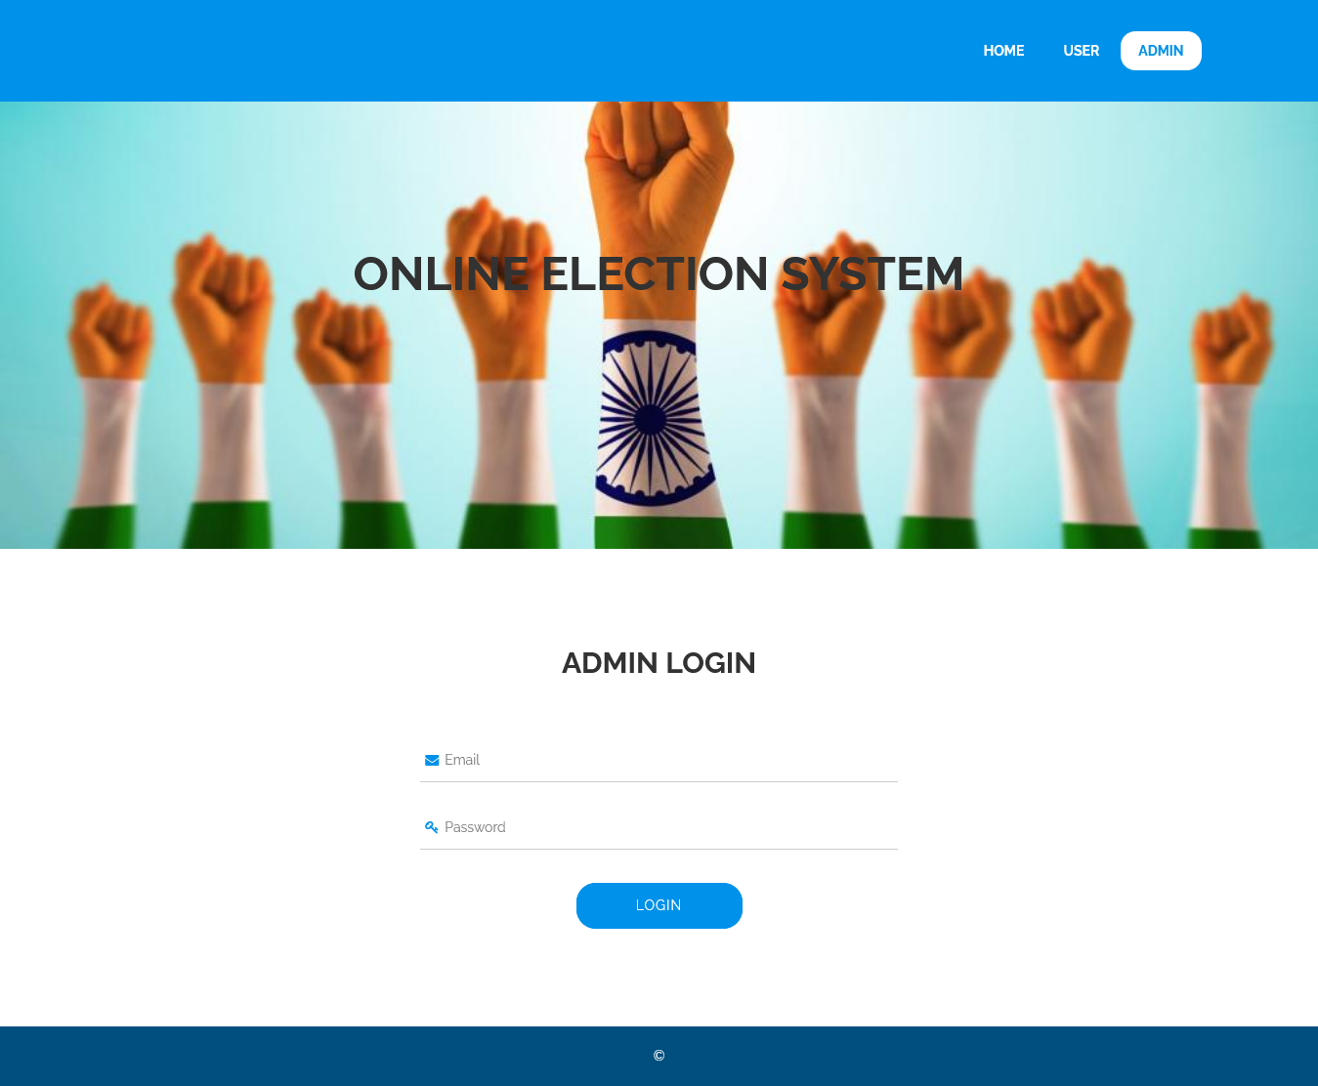

6.2.1. Admin Login page

**7. RESULTS & DISCUSSIONS**

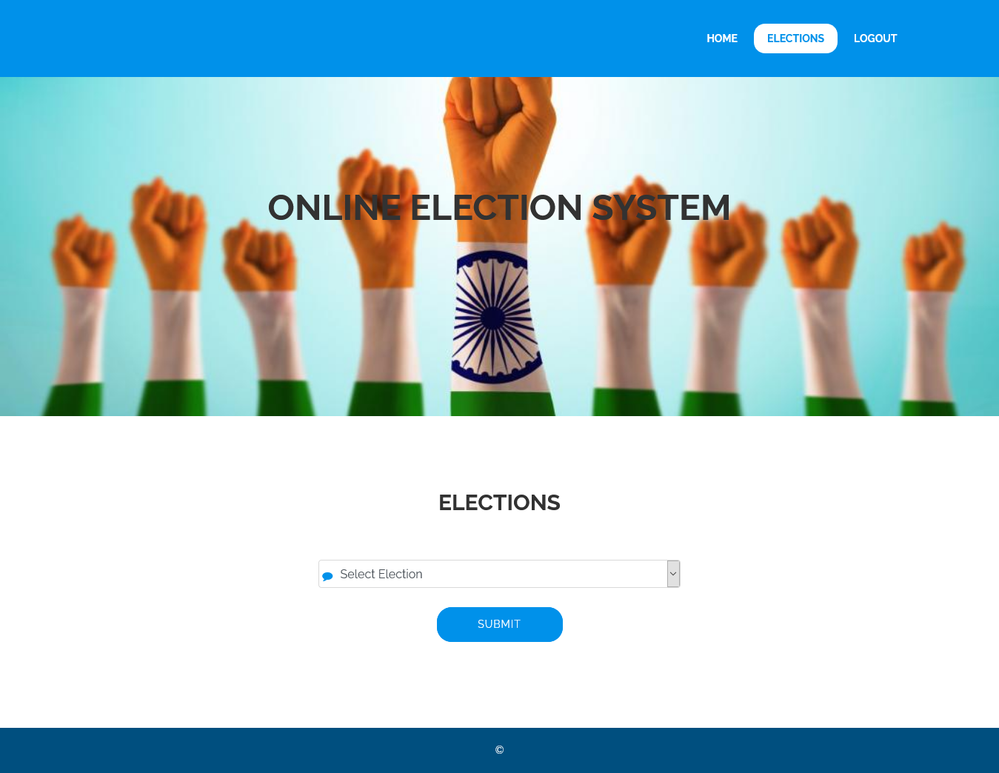

7.1 Information about upcoming Election page

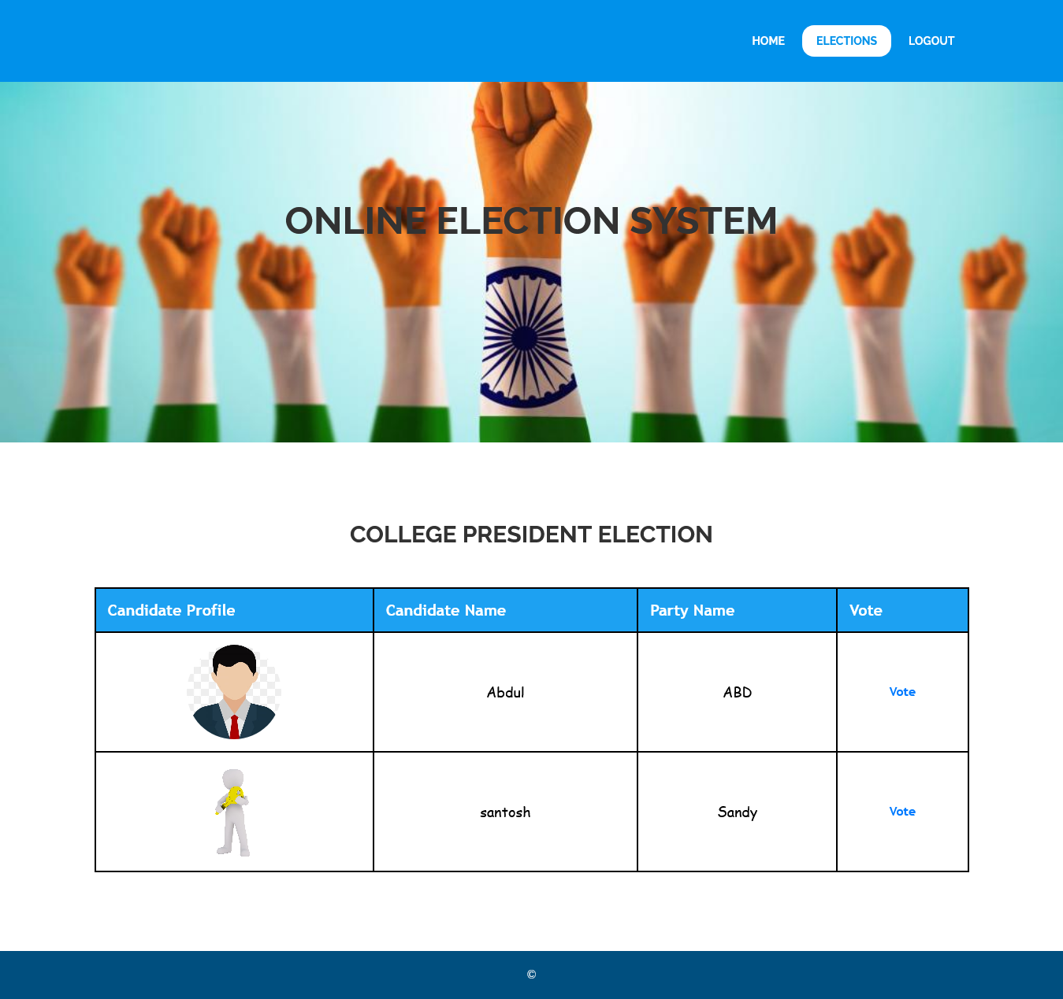

7.2. Candidate list page with vote casting option.

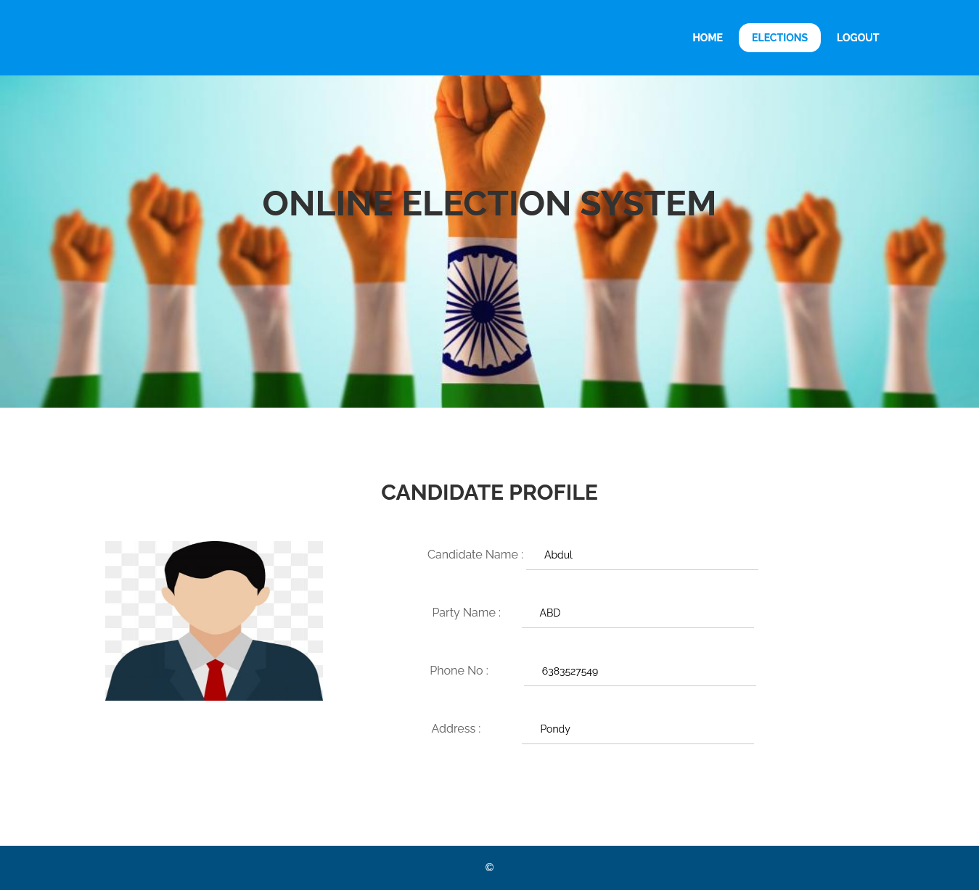

7.3. Candidate Profile Page

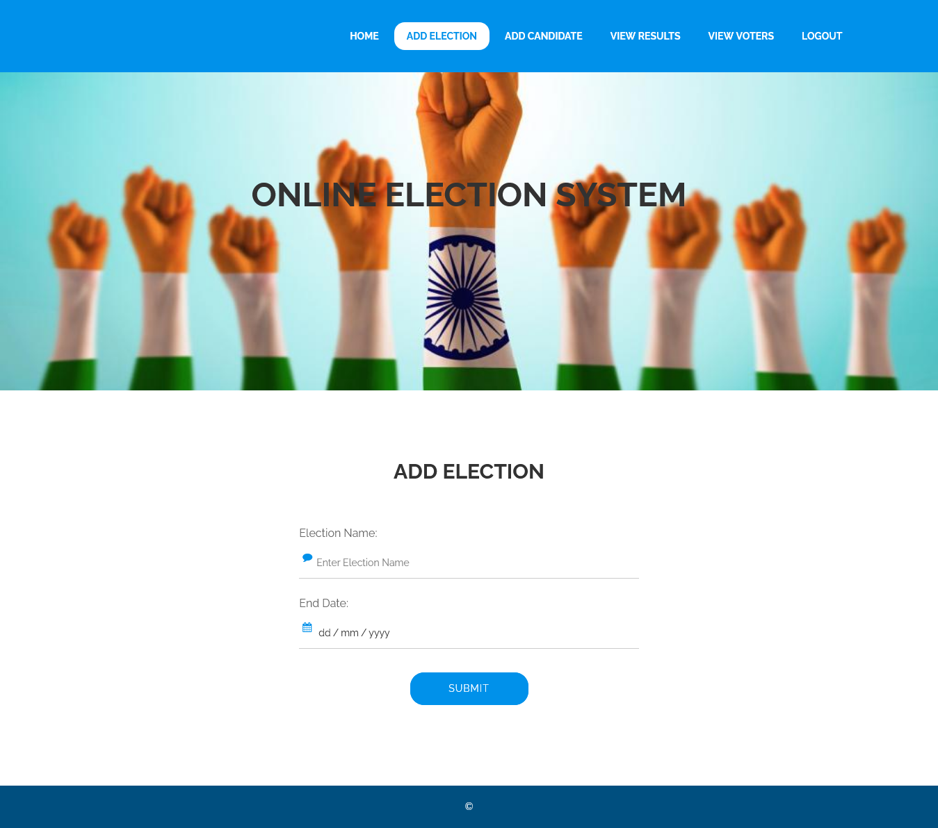

7.4. Adding upcoming elections.

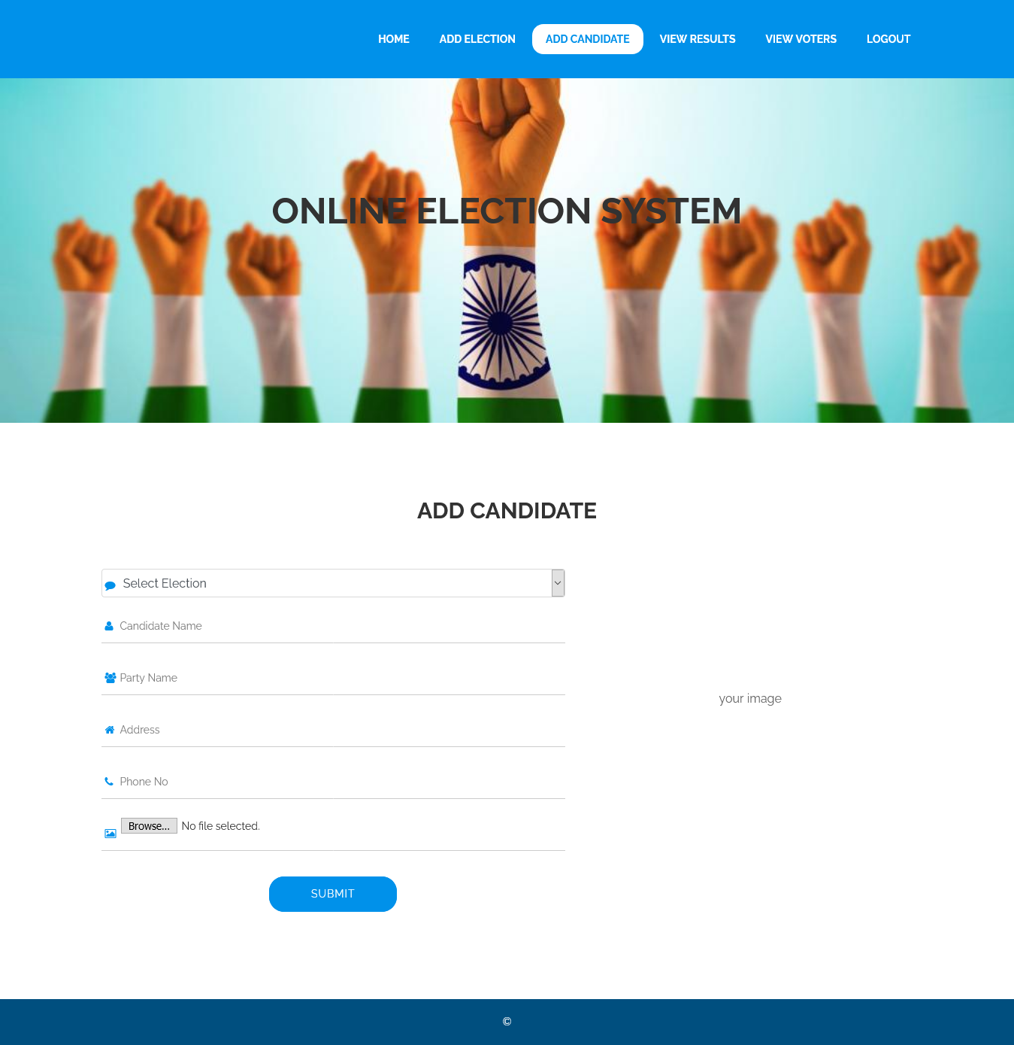

7.5. Adding Candidate details

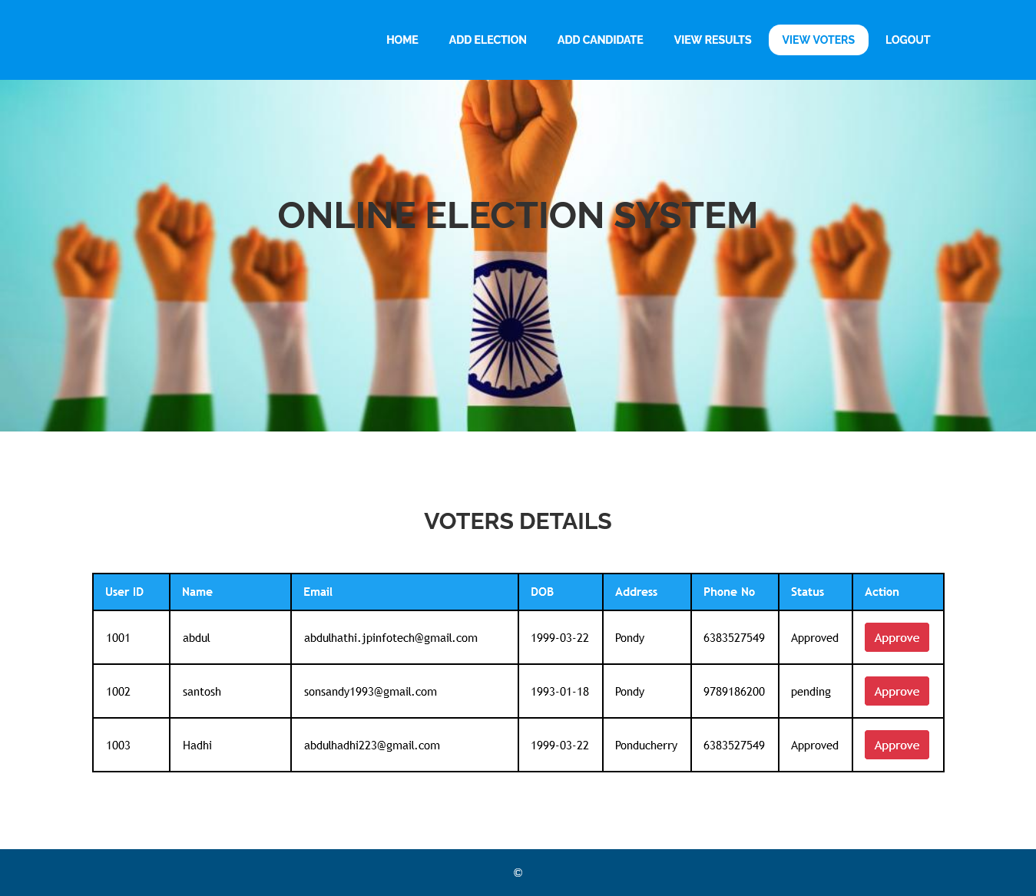

7.6. Voter Registration Approval

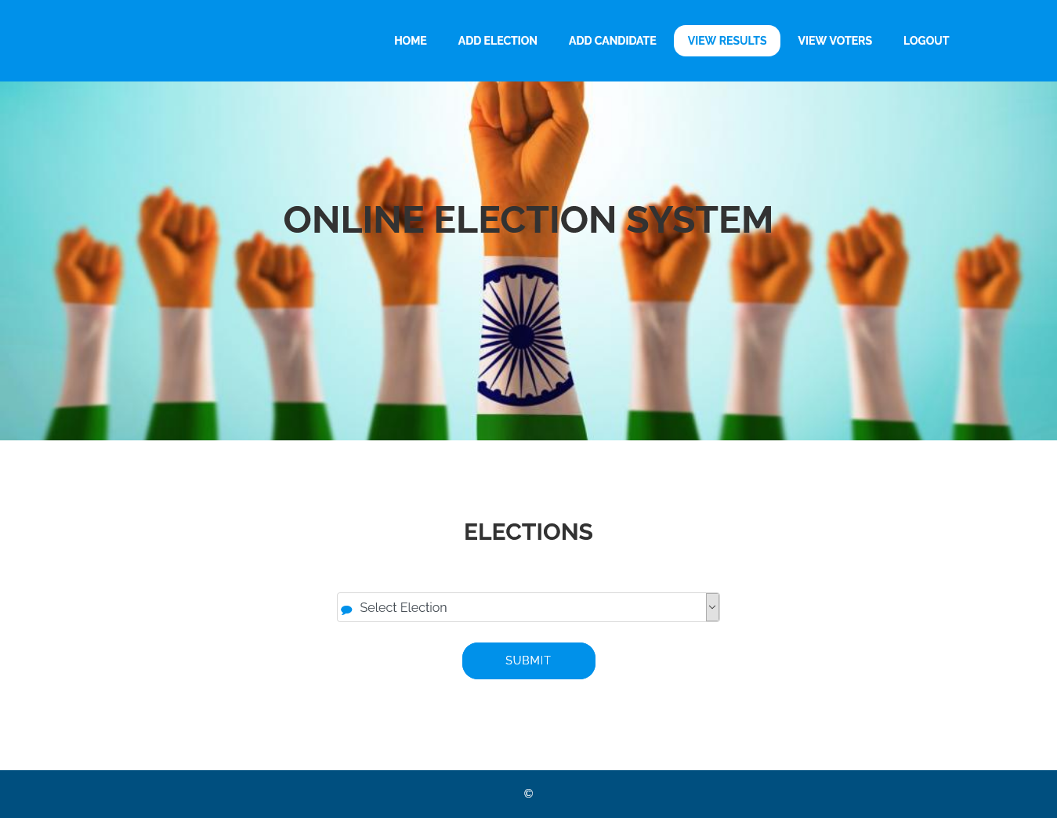

7.7. Upcoming Elections page

**8. ONLINE CERTIFICATION COURSE**

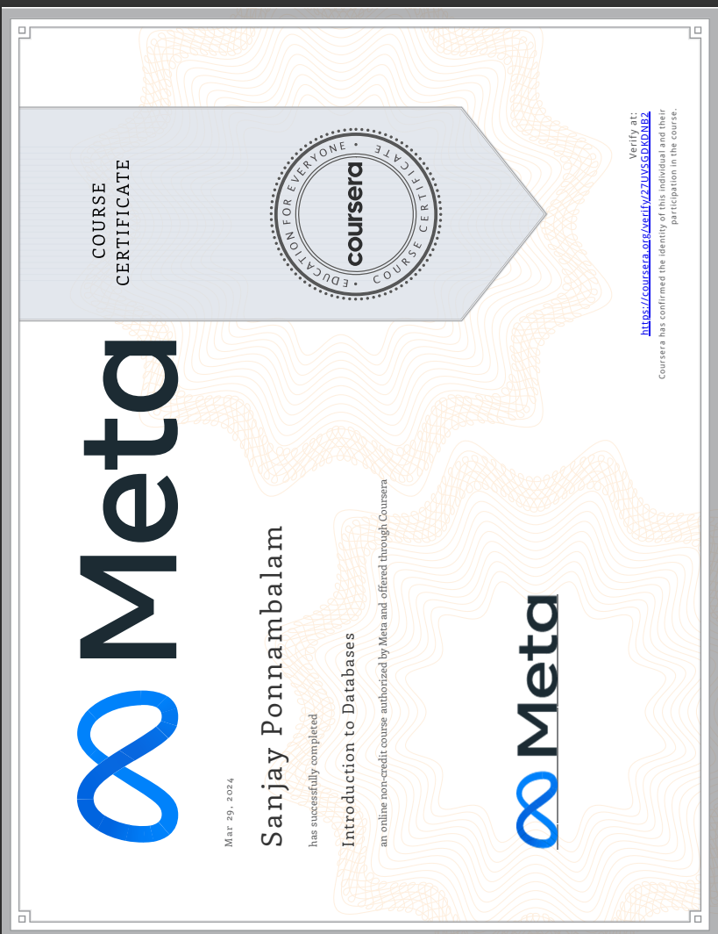

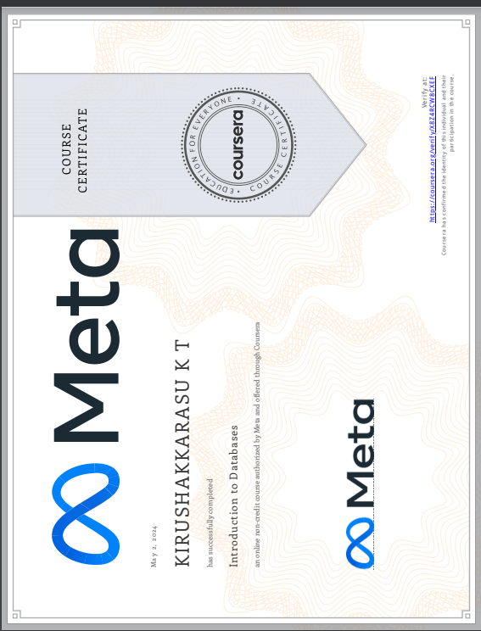

**9.CONCLUSION**

The development of the "VoteX - Campaign Compass" project has been a significant endeavor aimed at providing voters with a comprehensive platform to access campaign information and make informed decisions during electoral processes. Throughout the project lifecycle, various aspects ranging from database design to user interface development have been meticulously addressed to create a robust and user-friendly application. The VoteX project successfully addresses the need for transparency and accessibility in the electoral process by providing voters with easy access to information about candidates, campaigns, and political parties. By leveraging modern technologies and best practices in database management, software development, and user experience design, the project aims to empower voters and foster civic engagement. The implementation of transaction controls and concurrency techniques within the project's database management system ensures data integrity, consistency, and isolation, thereby enhancing the reliability and efficiency of the application. Through careful consideration of transactional processes and concurrency mechanisms, the project mitigates the risk of data corruption and maintains a high level of performance even under high user loads.

Furthermore, the VoteX project's user interface design focuses on usability and accessibility, ensuring that voters of all backgrounds can easily navigate the application and access relevant campaign information. User feedback mechanisms and iterative design processes have been employed to continually improve the application's user experience and address evolving user needs. Looking ahead, the VoteX project has the potential to serve as a valuable tool for voters, electoral authorities, and political organizations in promoting democratic participation and facilitating informed decision-making. By embracing emerging technologies and fostering collaboration between stakeholders, the project can continue to evolve and adapt to the changing landscape of electoral processes, ultimately contributing to the advancement of democracy and civic engagement.

In summary, the "VoteX - Campaign Compass" project represents a significant step towards enhancing transparency, accessibility, and participation in the electoral process. Through its comprehensive features, robust database management, and user-centric design, the project aims to empower voters and strengthen democratic values, paving the way for a more informed and engaged electorate.

**REFERENCES**

1. G. N. de los Santos, J. R. N. de los Santos and L. G. de los Santos, "e-voting kiosk: A Network Architecture School-based Registration and Voting System," 2020 IEEE 12th International Conference on Humanoid, Nanotechnology, Information Technology, Communication and Control, Environment, and Management (HNICEM), Manila, Philippines, 2020, pp. 1-5, doi: 10.1109/HNICEM51456.2020.9400135.
2. W. Jie and Z. Yu, "The realization of high-performance cluster management system based on autonomic computing," 2012 9th International Conference on Fuzzy Systems and Knowledge Discovery, Chongqing, China, 2012, pp. 2515-2518, doi: 10.1109/FSKD.2012.6234057
3. S. Z. T. Khoo et al., "Social Media Analytics: A Case Study of Singapore General Election 2020," 2020 IEEE International Conference on Big Data (Big Data), Atlanta, GA, USA, 2020, pp. 5730-5732, doi: 10.1109/BigData50022.2020.9378358.
4. O. Adetunji, "ECOR: A reference model for the management of electoral Supply Chain Support," 2015 International Conference on Industrial Engineering and Operations Management (IEOM), Dubai, United Arab Emirates, 2015, pp. 1-13, doi: 10.1109/IEOM.2015.7093937.
5. H. -C. Cahng and C. -C. Lo, "A Consensus-Based Leader Election Algorithm for Wireless Ad Hoc Networks," 2012 International Symposium on Computer, Consumer and Control, Taichung, Taiwan, 2012, pp. 232-235, doi: 10.1109/IS3C.2012.66.
6. G. Schryen and E. Rich, "Security in Large-Scale Internet Elections: A Retrospective Analysis of Elections in Estonia, The Netherlands, and Switzerland," in IEEE Transactions on Information Forensics and Security, vol. 4, no. 4, pp. 729-744, Dec. 2009, doi: 10.1109/TIFS.2009.2033230.
7. A. A. Obeidat and V. V. Gubarev, "Leader election in Peer-to-Peer systems," 2009 International Siberian Conference on Control and Communications, Tomsk, Russia, 2009, pp. 25-31, doi: 10.1109/SIBCON.2009.5044825.
8. A. Rully and H. Nakazato, "Tamper-proof Election Result Verification System in Resource Constrained Environments," 2018 International Conference on Computing and Network Communications (CoCoNet), Astana, Kazakhstan, 2018, pp. 250-257, doi: 10.1109/CoCoNet.2018.8476882.
9. O. Adetunji, "ECOR: A reference model for the management of electoral Supply Chain Support," pp. 1-13, doi: 10.1109/IEOM.2015.7093937.

**APPENDIX**

Implementation of Front End for the project codes



